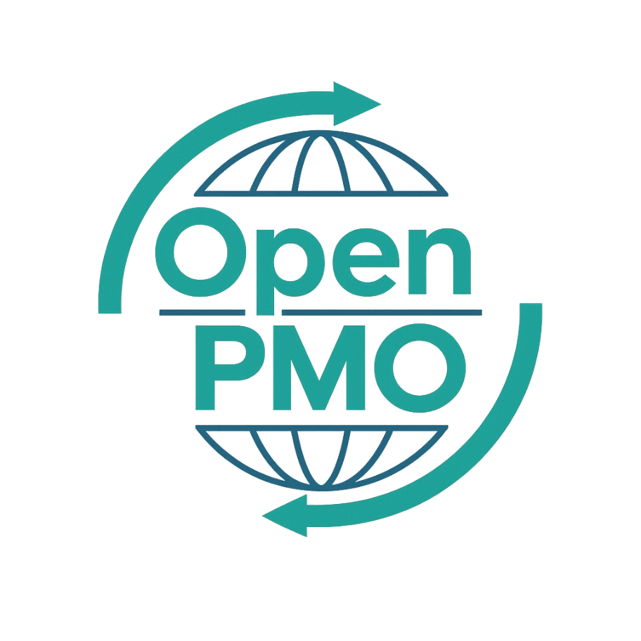
PROJECT TITLE
Project Closure Report

Author
[Email address]

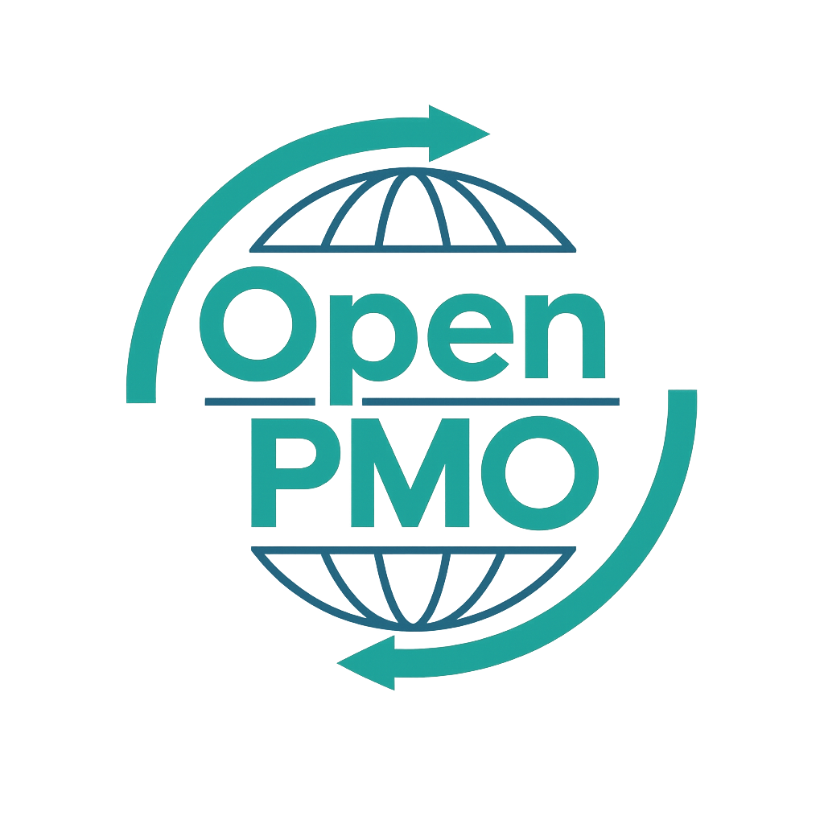
📄 Terms of Use
This resource is part of the Open PMO initiative to support project managers, business analysts, and teams with accessible, professional tools. You are welcome to use, adapt, and build upon this document freely.
1. Open Access & Adaptation
• You may copy, modify, and tailor this document for your own organisation or personal use.
• Attribution to Open PMO is appreciated but not required.
2. No Warranty or Liability
• This document is provided "as is," without warranties of any kind.
• Open PMO and its contributors are not liable for any outcomes resulting from its use or adaptation.
3. Responsibility for Customisation
• You are responsible for ensuring that any adapted version meets your organisation's legal, operational, and compliance standards.
• We recommend consulting with relevant stakeholders before implementation.
4. Respectful Use
• Please do not use this resource in ways that promote harm, discrimination, or unethical practices.
• If redistributed, do not misrepresent the original intent or authorship.

PROJECT CLOSURE REPORT 1

Open PMO — Project Management
Project Closure Report
Formally closing the project and confirming handover to business as usual

Project Name | [Project Name] | Version | 1.0
Date | [DD MMM YYYY] | Author | [Name]
Status | DRAFT | Sponsor | [Name]

1. Project Summary
Project Name | [Name] | Project Manager | [Name]
Start Date | [Date] | End Date | [Date]
Original Budget | £ | Final Cost | £
Sponsor | [Name] | Overall RAG | Green / Amber / Red

2. Objectives — Delivered?
💡 List the original project objectives and confirm whether each was achieved.
Objective | Status | Notes
 | ✓ Achieved / ✗ Not achieved
 | ✓ Achieved / ✗ Not achieved
 | ✓ Achieved / ✗ Not achieved
 | ✓ Achieved / ✗ Not achieved

3. Deliverables Accepted
Deliverable | Accepted by | Date
 |  | [Date]
 |  | [Date]
 |  | [Date]
 |  | [Date]

4. Budget Summary
Category | Budgeted (£) | Actual (£) | Variance (£) | Notes
Internal resource | £ | £ | £
External / suppliers | £ | £ | £
Technology | £ | £ | £
Other | £ | £ | £
TOTAL | £ | £ | £

5. Benefits Realised
💡 Even if formal benefits tracking happens post-closure, capture early indicators here.
Benefit | Baseline | Current | Status
 |  |  | On track / At risk
 |  |  | On track / At risk
 |  |  | On track / At risk

6. Lessons Learned

6.1 What went well
- [Specific thing that worked well — be concrete, not generic]
- [Specific thing that worked well]

6.2 What to improve next time
- [Specific improvement — include root cause where known]
- [Specific improvement]

6.3 Recommendations for future projects
- [Actionable recommendation the organisation should adopt]
- [Actionable recommendation]

7. Outstanding Actions at Closure
💡 Any items not complete at closure should be formally handed over — not left unresolved.
Outstanding action | Handed to | Target date
 |  | [Date]
 |  | [Date]
 |  | [Date]

8. Formal Closure Sign-off
By signing below, stakeholders confirm the project is formally closed and all deliverables have been accepted.

Name | Role | Signature | Date
 | Project Manager
 | Business Owner
 | Project Sponsor

© Open PMO — openpmo.org — Free to use, adapt and share.

