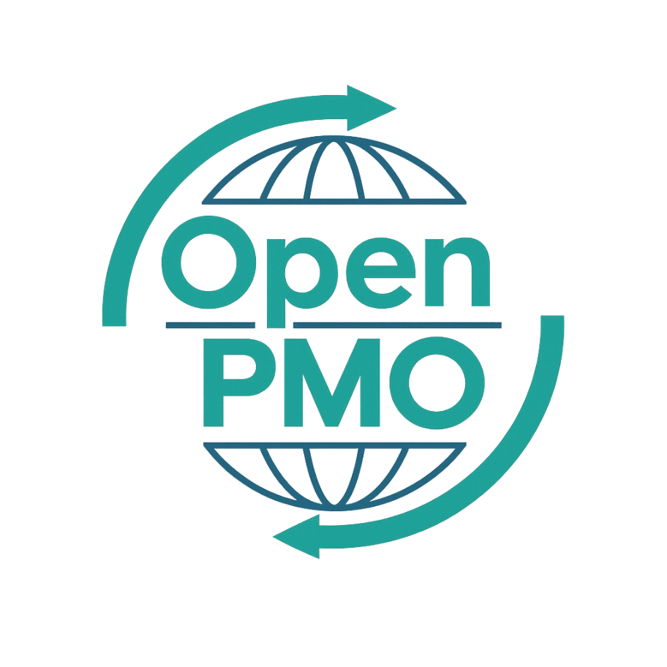
PROJECT TITLE
Project Brief

Author
[Email address]

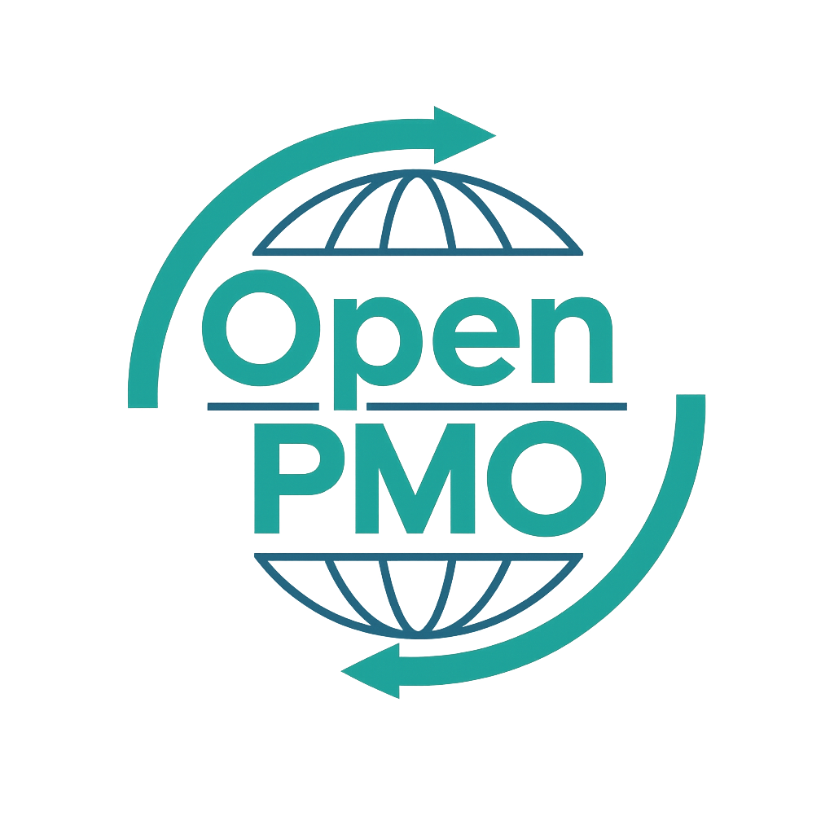
📄 Terms of Use
This resource is part of the Open PMO initiative to support project managers, business analysts, and teams with accessible, professional tools. You are welcome to use, adapt, and build upon this document freely.
1. Open Access & Adaptation
• You may copy, modify, and tailor this document for your own organisation or personal use.
• Attribution to Open PMO is appreciated but not required.
2. No Warranty or Liability
• This document is provided "as is," without warranties of any kind.
• Open PMO and its contributors are not liable for any outcomes resulting from its use or adaptation.
3. Responsibility for Customisation
• You are responsible for ensuring that any adapted version meets your organisation's legal, operational, and compliance standards.
• We recommend consulting with relevant stakeholders before implementation.
4. Respectful Use
• Please do not use this resource in ways that promote harm, discrimination, or unethical practices.
• If redistributed, do not misrepresent the original intent or authorship.

PROJECT BRIEF 1

Open PMO — Project Management
Project Brief
A lightweight project initiation document for smaller or internal initiatives

Project Name | [Project Name] | Version | 1.0
Date | [DD MMM YYYY] | Author | [Name]
Status | DRAFT | Sponsor | [Name]

1. Project Overview
💡 Keep this concise — a Project Brief is not a full Business Case. 1-2 paragraphs maximum.

2. Business Need

2.1 Problem or opportunity
[What problem are we solving, or what opportunity are we pursuing? Be specific.]

2.2 Consequences of inaction
- [What happens if we do nothing?]
- [Quantify where possible — cost, risk, missed opportunity]

3. Proposed Solution
[Describe the proposed approach in plain English. What will we build, change, or deliver?]

4. Scope

4.1 In scope
- [What is included in this project]
- [What is included in this project]

4.2 Out of scope
- [What is explicitly excluded]
- [What is explicitly excluded]

5. Deliverables
Deliverable | Owner | Target Date
 |  | [Date]
 |  | [Date]
 |  | [Date]
 |  | [Date]

6. Indicative Timeline
Phase | Activities | Start | End
Initiation |  | [Date] | [Date]
Planning |  | [Date] | [Date]
Delivery |  | [Date] | [Date]
Closure |  | [Date] | [Date]

7. Resource & Budget
Resource | Role | Days | Cost (£)
Internal resource |  |  | £
External / contractor |  |  | £
Tools / licences |  |  | £
Contingency (10%) |  |  | £

8. Key Risks
# | Risk | Likelihood | Impact | Mitigation
1 |  | H/M/L | H/M/L
2 |  | H/M/L | H/M/L
3 |  | H/M/L | H/M/L

9. Approval
💡 This document authorises the project to proceed to planning. Secure sign-off before committing resource.

Name | Role | Signature | Date
 | Project Manager
 | Project Sponsor
 | Business Owner

© Open PMO — openpmo.org — Free to use, adapt and share.

