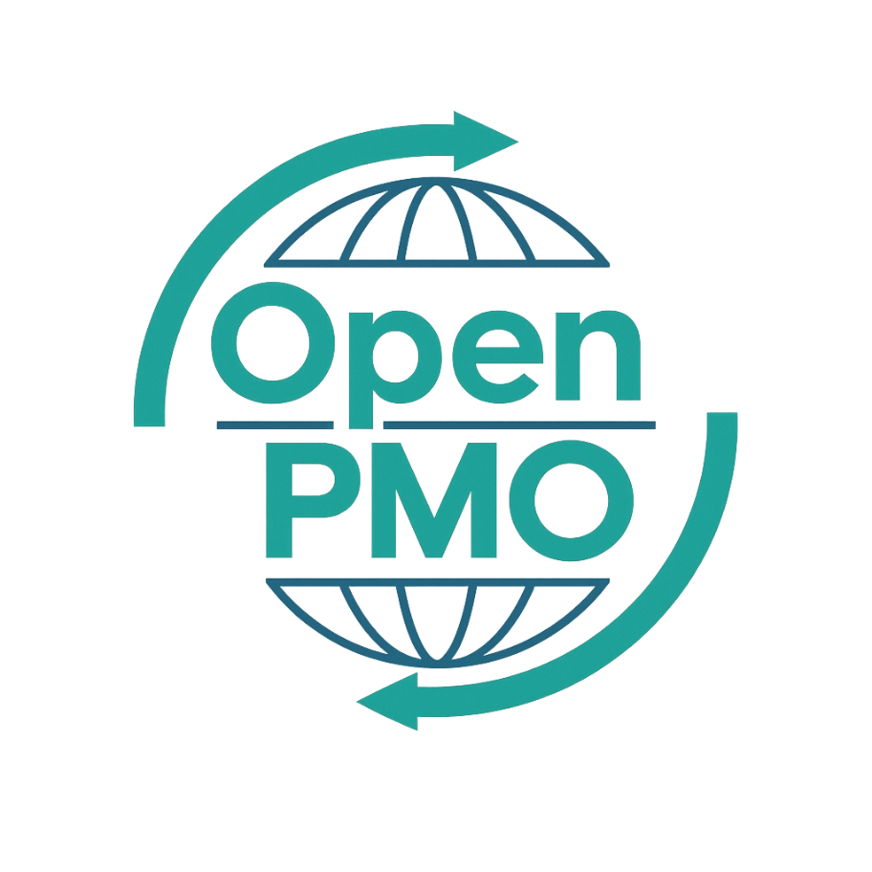
PROJECT TITLE
Workshop Facilitation Guide

Author
[Email address]

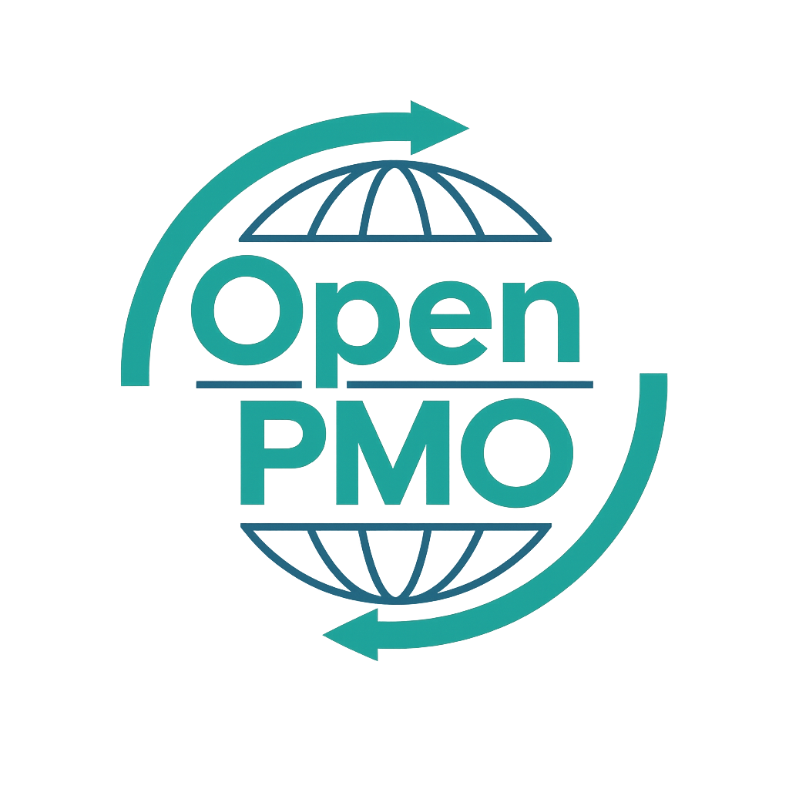
📄 Terms of Use
This resource is part of the Open PMO initiative to support project managers, business analysts, and teams with accessible, professional tools. You are welcome to use, adapt, and build upon this document freely.
1. Open Access & Adaptation
• You may copy, modify, and tailor this document for your own organisation or personal use.
• Attribution to Open PMO is appreciated but not required.
2. No Warranty or Liability
• This document is provided "as is," without warranties of any kind.
• Open PMO and its contributors are not liable for any outcomes resulting from its use or adaptation.
3. Responsibility for Customisation
• You are responsible for ensuring that any adapted version meets your organisation's legal, operational, and compliance standards.
• We recommend consulting with relevant stakeholders before implementation.
4. Respectful Use
• Please do not use this resource in ways that promote harm, discrimination, or unethical practices.
• If redistributed, do not misrepresent the original intent or authorship.

WORKSHOP FACILITATION GUIDE 1

Open PMO — Business Analysis
Workshop Facilitation Guide
Planning and running effective requirements workshops from preparation to output

Project Name | [Project Name] | Version | 1.0
Date | [DD MMM YYYY] | Author | [Name]
Business Analyst | [Name] | Status | DRAFT

Revision History
Version | Date | Changes | Author
0.1 | [Date] | Initial draft | [Name]
1.0 | [Date] | Approved for use | [Name]

1. Workshop Overview
Workshop Title |  | Date & Time
Facilitator |  | Scribe
Location / Link |  | No. of Participants
Project |  | Reference

2. Objectives & Outcomes
💡 Be specific. "Gather requirements" is not an objective. "Agree the top 10 functional requirements for the customer portal login flow" is.

2.1 Workshop objectives
- [Objective 1 — specific and measurable]
- [Objective 2]
- [Objective 3]

2.2 Outputs expected from this session
- [Output 1 — e.g. agreed requirements list]
- [Output 2 — e.g. process map reviewed and signed off]

3. Participants
Name | Role / Department | Type | Confirmed
 |  | Participant / Observer | Y / N
 |  | Participant / Observer | Y / N
 |  | Participant / Observer | Y / N
 |  | Participant / Observer | Y / N
 |  | Participant / Observer | Y / N
 |  | Participant / Observer | Y / N

4. Pre-Workshop Preparation

Facilitator checklist
- Send invitation and pre-read materials at least 5 days in advance
- Book room / set up Teams meeting with dial-in details
- Prepare materials — slides, templates, sticky note boards, or Miro/Mural board
- Brief the scribe on what to capture and how
- Review previous session notes or relevant documentation
- Prepare icebreaker or warm-up activity if needed
- Set up timekeeping — be ready to manage the agenda firmly

Pre-read materials to send participants
- [Document 1 — e.g. current process map]
- [Document 2 — e.g. draft requirements list]

5. Agenda
Time | Duration | Activity | Facilitator Notes
 | 10 mins | Welcome & introductions
 | 10 mins | Objectives & ground rules
 | 10 mins | Context / scene-setting
 | 10 mins | Working session 1
 | 10 mins | Break
 | 10 mins | Working session 2
 | 10 mins | Prioritisation
 | 10 mins | Actions & next steps
 | 10 mins | Close

6. Facilitation Notes

Ground rules to set at the start
- One conversation at a time
- All contributions are valued — there are no wrong answers
- Challenge ideas, not people
- Phones away where possible — be present
- Decisions made today will be recorded and circulated

If the group goes off track
"That's a really important point — let's capture it in the parking lot and make sure we address it. For now, let's keep focused on [topic]."

If one person is dominating
"Thank you — really helpful. I want to make sure we hear from everyone. [Name], what's your view?"

7. Output Capture

7.1 Decisions made
# | Decision | Made by | Date
1
2
3

7.2 Actions agreed
# | Action | Owner | Due Date
1 |  |  | [Date]
2 |  |  | [Date]
3 |  |  | [Date]
4 |  |  | [Date]
5 |  |  | [Date]

7.3 Parking lot (items for later)
# | Item | How to resolve
1
2
3

© Open PMO — openpmo.org — Free to use, adapt and share.

