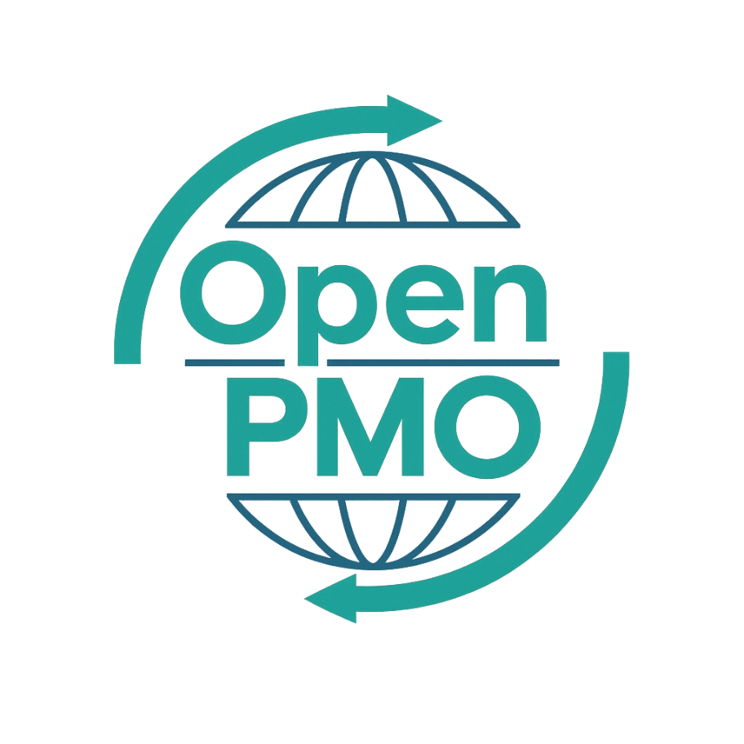
PROJECT TITLE
User Story Template

Author
[Email address]

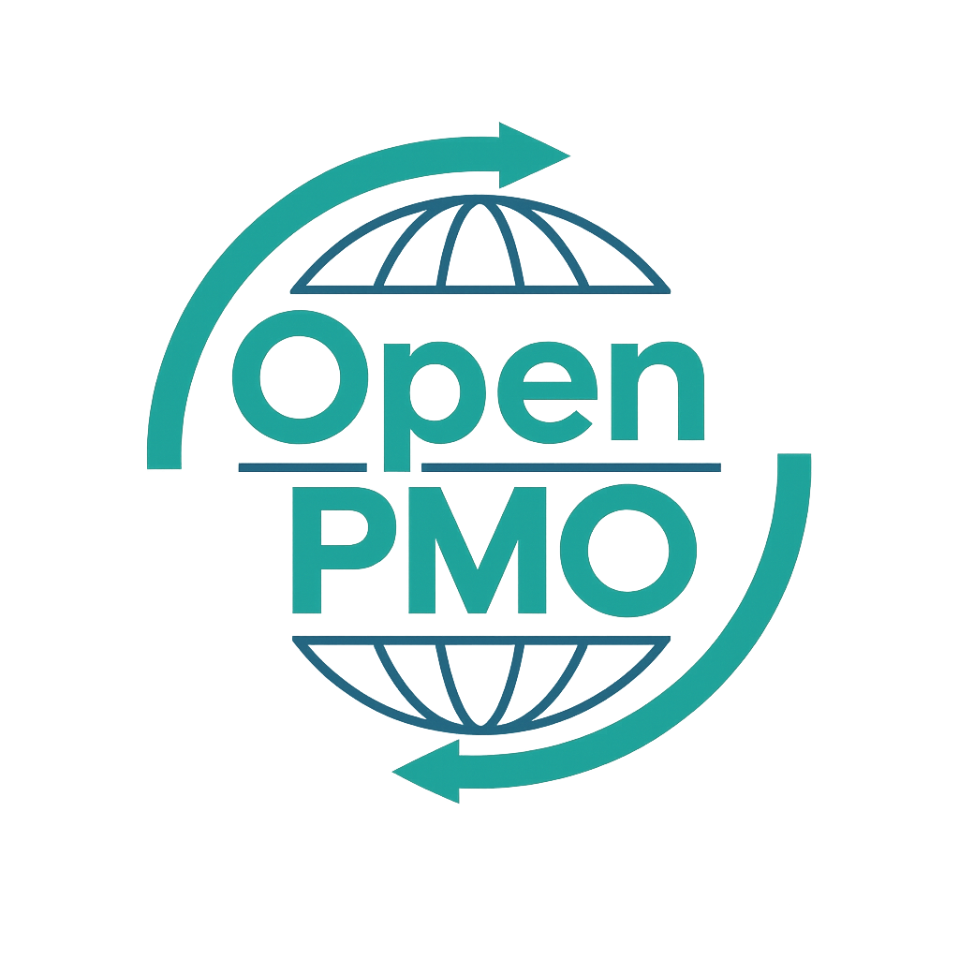
📄 Terms of Use
This resource is part of the Open PMO initiative to support project managers, business analysts, and teams with accessible, professional tools. You are welcome to use, adapt, and build upon this document freely.
1. Open Access & Adaptation
• You may copy, modify, and tailor this document for your own organisation or personal use.
• Attribution to Open PMO is appreciated but not required.
2. No Warranty or Liability
• This document is provided "as is," without warranties of any kind.
• Open PMO and its contributors are not liable for any outcomes resulting from its use or adaptation.
3. Responsibility for Customisation
• You are responsible for ensuring that any adapted version meets your organisation's legal, operational, and compliance standards.
• We recommend consulting with relevant stakeholders before implementation.
4. Respectful Use
• Please do not use this resource in ways that promote harm, discrimination, or unethical practices.
• If redistributed, do not misrepresent the original intent or authorship.

USER STORY TEMPLATE 1

Open PMO — Business Analysis
User Story Template
Capturing agile requirements in a consistent, sprint-ready format

Project Name | [Project Name] | Version | 1.0
Date | [DD MMM YYYY] | Author | [Name]
Business Analyst | [Name] | Status | DRAFT

Revision History
Version | Date | Changes | Author
0.1 | [Date] | Initial draft | [Name]
1.0 | [Date] | Approved for use | [Name]

1. Overview
💡 Describe the product, feature, or sprint this user story set covers.
Product / Feature |  | Sprint / Release
Product Owner |  | Business Analyst

2. User Story Format
Standard format
As a [type of user], I want to [action] so that [benefit].

3. Epics
Epic ID | Epic Name | Description
EP-01
EP-02
EP-03

4. User Stories

US-001
Epic
As a | [user type]
I want to | [action]
So that | [benefit]
Priority | M = Must / S = Should / C = Could / W = Won't
Story Points
Acceptance Criteria | ✓ Given [context], when [action], then [outcome].  ✓ Given [context], when [action], then [outcome].  ✓ Given [context], when [action], then [outcome].

US-002
Epic
As a | [user type]
I want to | [action]
So that | [benefit]
Priority | M = Must / S = Should / C = Could / W = Won't
Story Points
Acceptance Criteria | ✓ Given [context], when [action], then [outcome].  ✓ Given [context], when [action], then [outcome].  ✓ Given [context], when [action], then [outcome].

US-003
Epic
As a | [user type]
I want to | [action]
So that | [benefit]
Priority | M = Must / S = Should / C = Could / W = Won't
Story Points
Acceptance Criteria | ✓ Given [context], when [action], then [outcome].  ✓ Given [context], when [action], then [outcome].  ✓ Given [context], when [action], then [outcome].

US-004
Epic
As a | [user type]
I want to | [action]
So that | [benefit]
Priority | M = Must / S = Should / C = Could / W = Won't
Story Points
Acceptance Criteria | ✓ Given [context], when [action], then [outcome].  ✓ Given [context], when [action], then [outcome].  ✓ Given [context], when [action], then [outcome].

US-005
Epic
As a | [user type]
I want to | [action]
So that | [benefit]
Priority | M = Must / S = Should / C = Could / W = Won't
Story Points
Acceptance Criteria | ✓ Given [context], when [action], then [outcome].  ✓ Given [context], when [action], then [outcome].  ✓ Given [context], when [action], then [outcome].

5. Definition of Done
💡 The Definition of Done applies to all user stories in this set. Adjust to suit your team.
- Code written and peer-reviewed
- Unit tests written and passing
- Acceptance criteria signed off by Product Owner
- No known defects above severity 3
- Documentation updated
- Deployed to test environment

© Open PMO — openpmo.org — Free to use, adapt and share.

