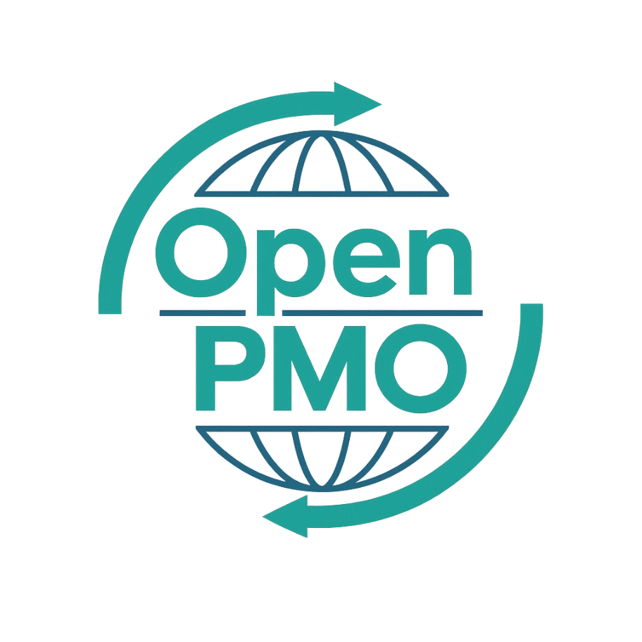
PROJECT TITLE
Business Case

Author
[Email address]

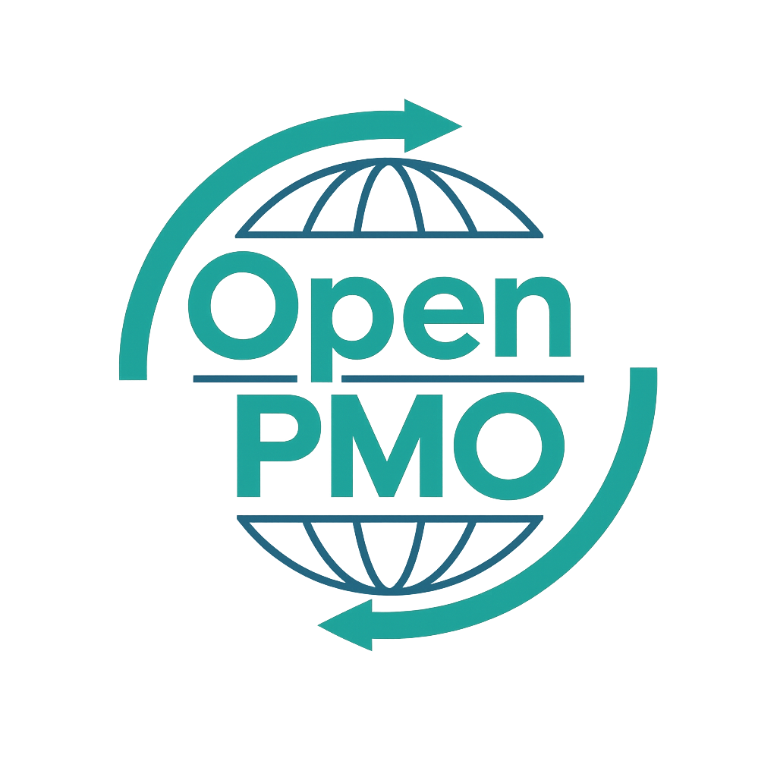
📄 Terms of Use
This resource is part of the Open PMO initiative to support project managers, business analysts, and teams with accessible, professional tools. You are welcome to use, adapt, and build upon this document freely.
1. Open Access & Adaptation
• You may copy, modify, and tailor this document for your own organisation or personal use.
• Attribution to Open PMO is appreciated but not required.
2. No Warranty or Liability
• This document is provided "as is," without warranties of any kind.
• Open PMO and its contributors are not liable for any outcomes resulting from its use or adaptation.
3. Responsibility for Customisation
• You are responsible for ensuring that any adapted version meets your organisation's legal, operational, and compliance standards.
• We recommend consulting with relevant stakeholders before implementation.
4. Respectful Use
• Please do not use this resource in ways that promote harm, discrimination, or unethical practices.
• If redistributed, do not misrepresent the original intent or authorship.

BUSINESS CASE 1

Open PMO — Business Analysis
Business Case
Making the case for investment with structured analysis and a clear recommendation

Project Name | [Project Name] | Version | 1.0
Date | [DD MMM YYYY] | Author | [Name]
Business Analyst | [Name] | Status | DRAFT

Revision History
Version | Date | Changes | Author
0.1 | [Date] | Initial draft | [Name]
1.0 | [Date] | Approved for use | [Name]

1. Executive Summary
💡 Write this last. 3–5 sentences covering: what is proposed, why it is needed, what it costs, what it delivers, and your recommendation.

2. Background & Strategic Context

2.1 Background

2.2 Strategic Alignment
Strategic Objective | How This Initiative Supports It

3. Problem Statement

3.1 Current situation

3.2 Impact of doing nothing
- [Consequence 1 — quantify where possible]
- [Consequence 2]
- [Consequence 3]

4. Options Considered
💡 Always include at least three options: do nothing, recommended approach, and one alternative. This demonstrates rigour.
Option | Description | Cost | Recommendation
Option A — Do Nothing | Continue as-is — accept current risk and cost | £0 | Not recommended
Option B — Recommended |  |  | ★ Recommended
Option C — Alternative |  |  | Not recommended

5. Costs & Benefits (Recommended Option)

5.1 Costs
Cost Category | Year 1 (£) | Year 2 (£) | Year 3 (£) | Total (£)
Internal Resource | £ | £ | £ | £
External / Suppliers | £ | £ | £ | £
Technology / Licences | £ | £ | £ | £
Infrastructure | £ | £ | £ | £
Contingency (10%) | £ | £ | £ | £
TOTAL COST | £ | £ | £ | £

5.2 Benefits
Benefit | Type | Value (pa) | Realised From
[Benefit 1] | Financial | £
[Benefit 2] | Efficiency | £
[Benefit 3] | Risk reduction | £
TOTAL BENEFITS |  | £

6. Risk Assessment
# | Risk | Likelihood | Impact | Mitigation
1 |  | H / M / L | H / M / L
2 |  | H / M / L | H / M / L
3 |  | H / M / L | H / M / L

7. Recommendation & Next Steps
[State your recommendation clearly in 2–3 sentences. What should happen, when, and who needs to approve it?]

Next Step | Owner | By When
Approve Business Case |  | [Date]
Appoint Project Sponsor |  | [Date]
Initiate Project Charter |  | [Date]
Procure delivery team |  | [Date]

8. Sign-off
Name | Role | Signature | Date
 | Business Analyst
 | Project Manager
 | Project Sponsor
 | Portfolio Board Chair

© Open PMO — openpmo.org — Free to use, adapt and share.

