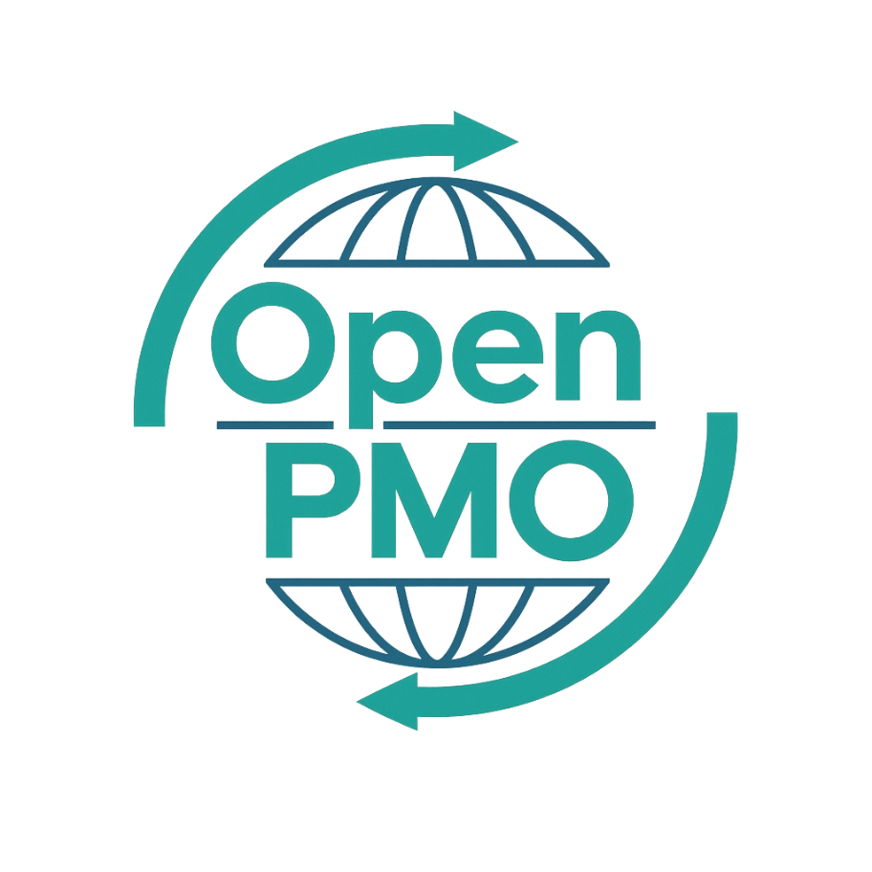
PROJECT TITLE
Gap Analysis

Author
[Email address]

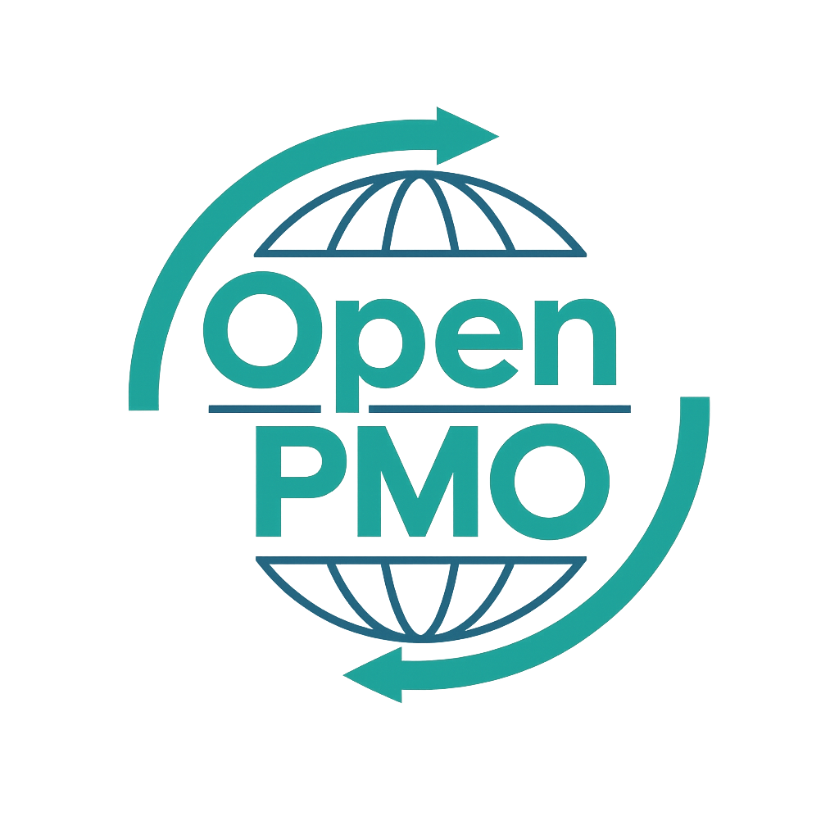
📄 Terms of Use
This resource is part of the Open PMO initiative to support project managers, business analysts, and teams with accessible, professional tools. You are welcome to use, adapt, and build upon this document freely.
1. Open Access & Adaptation
• You may copy, modify, and tailor this document for your own organisation or personal use.
• Attribution to Open PMO is appreciated but not required.
2. No Warranty or Liability
• This document is provided "as is," without warranties of any kind.
• Open PMO and its contributors are not liable for any outcomes resulting from its use or adaptation.
3. Responsibility for Customisation
• You are responsible for ensuring that any adapted version meets your organisation's legal, operational, and compliance standards.
• We recommend consulting with relevant stakeholders before implementation.
4. Respectful Use
• Please do not use this resource in ways that promote harm, discrimination, or unethical practices.
• If redistributed, do not misrepresent the original intent or authorship.

GAP ANALYSIS 1

Open PMO — Business Analysis
Gap Analysis
Comparing current capabilities against target requirements to define what needs to change

Project Name | [Project Name] | Version | 1.0
Date | [DD MMM YYYY] | Author | [Name]
Business Analyst | [Name] | Status | DRAFT

Revision History
Version | Date | Changes | Author
0.1 | [Date] | Initial draft | [Name]
1.0 | [Date] | Approved for use | [Name]

1. Purpose
[Describe the purpose of this gap analysis — what capability, process, or system is being assessed and why.]

2. Current State Summary
💡 Describe the as-is position across the four dimensions below. Be specific — use data and evidence where possible.

People
💡 Roles, skills, capacity, and ways of working

Process
💡 Key processes, workflows, and governance

Technology
💡 Systems, tools, and infrastructure

Data
💡 Data quality, access, and management

3. Future State Vision
💡 Describe the to-be position — what good looks like after this change. Be specific about measurable outcomes.

4. Gap Identification
💡 For each gap: rate Impact as High / Medium / Low. Priority = how urgently it must be addressed.
# | Area | Current State | Target State | Impact | Priority
1 |  |  |  | H / M / L | High / Medium / Low
2 |  |  |  | H / M / L | High / Medium / Low
3 |  |  |  | H / M / L | High / Medium / Low
4 |  |  |  | H / M / L | High / Medium / Low
5 |  |  |  | H / M / L | High / Medium / Low
6 |  |  |  | H / M / L | High / Medium / Low

5. Root Cause Analysis
💡 For the highest-priority gaps, identify the underlying root cause rather than the surface symptom.

Gap 1: [Gap title]
Root Cause
Contributing Factors
Evidence

Gap 2: [Gap title]
Root Cause
Contributing Factors
Evidence

6. Recommendations
# | Gap Ref | Recommendation | Priority | Owner
1 | Gap 1 |  | High / Medium / Low
2 | Gap 2 |  | High / Medium / Low
3 | Gap 3 |  | High / Medium / Low
4 | Gap 4 |  | High / Medium / Low
5 | Gap 5 |  | High / Medium / Low

7. Sign-off
Name | Role | Signature | Date
 | Business Analyst
 | Business Owner
 | Project Sponsor

© Open PMO — openpmo.org — Free to use, adapt and share.

