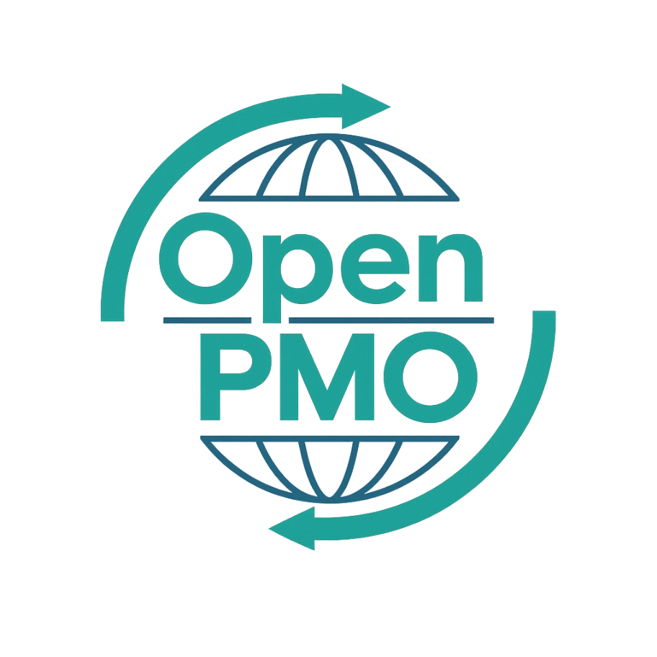
PROJECT TITLE
Use Case Template

Author
[Email address]

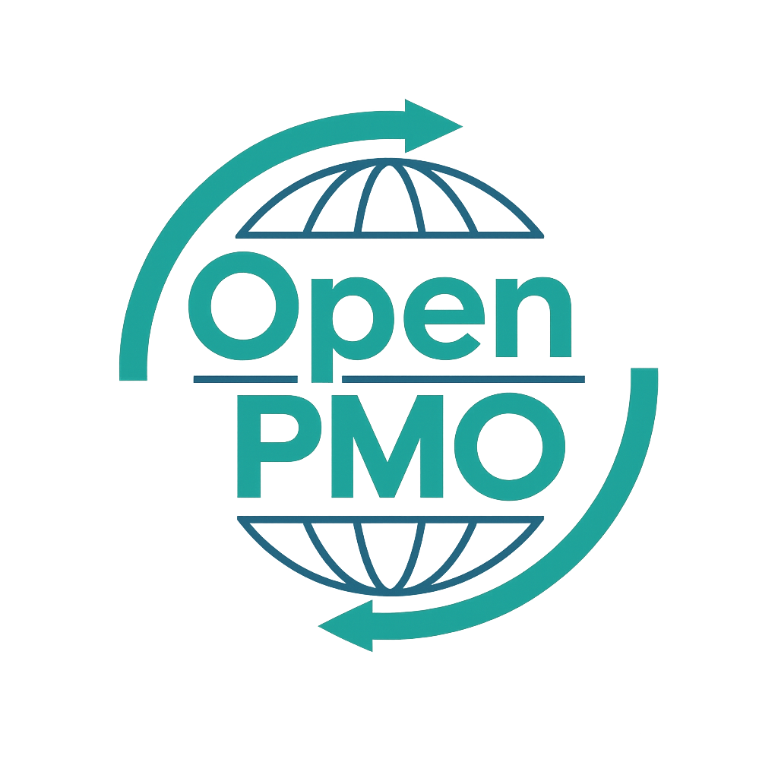
📄 Terms of Use
This resource is part of the Open PMO initiative to support project managers, business analysts, and teams with accessible, professional tools. You are welcome to use, adapt, and build upon this document freely.
1. Open Access & Adaptation
• You may copy, modify, and tailor this document for your own organisation or personal use.
• Attribution to Open PMO is appreciated but not required.
2. No Warranty or Liability
• This document is provided "as is," without warranties of any kind.
• Open PMO and its contributors are not liable for any outcomes resulting from its use or adaptation.
3. Responsibility for Customisation
• You are responsible for ensuring that any adapted version meets your organisation's legal, operational, and compliance standards.
• We recommend consulting with relevant stakeholders before implementation.
4. Respectful Use
• Please do not use this resource in ways that promote harm, discrimination, or unethical practices.
• If redistributed, do not misrepresent the original intent or authorship.

USE CASE TEMPLATE 1

Open PMO — Business Analysis
Use Case Template
Structured documentation of system interactions and actor behaviours

Project Name | [Project Name] | Version | 1.0
Date | [DD MMM YYYY] | Author | [Name]
Business Analyst | [Name] | Status | DRAFT

Revision History
Version | Date | Changes | Author
0.1 | [Date] | Initial draft | [Name]
1.0 | [Date] | Approved for use | [Name]

1. Overview
💡 Briefly describe the system or module these use cases cover and what problem they address.

2. Actor Definitions
💡 List every actor who interacts with the system. Primary actors initiate use cases; secondary actors are involved in the flow.
Actor | Type | Description
[Actor 1] | Primary
[Actor 2] | Primary
[Actor 3] | Primary
[External System] | Secondary

3. Use Cases
💡 Complete one section per use case. Number them UC-001, UC-002 etc. for traceability.

UC-001: [Use Case Name]
Use Case ID | UC-001
Goal / Objective
Primary Actor
Secondary Actors
Trigger | [What event starts this use case?]
Preconditions | [What must be true before this use case can begin?]
Main Success Flow
Step 1
Step 2
Step 3
Step 4
Step 5
Alternative Flows
Alt A | [Describe alternative or exception path]
Postconditions | [What is true after successful completion?]
Business Rules
Priority | Must Have / Should Have / Could Have

UC-002: [Use Case Name]
Use Case ID | UC-002
Goal / Objective
Primary Actor
Secondary Actors
Trigger | [What event starts this use case?]
Preconditions | [What must be true before this use case can begin?]
Main Success Flow
Step 1
Step 2
Step 3
Step 4
Step 5
Alternative Flows
Alt A | [Describe alternative or exception path]
Postconditions | [What is true after successful completion?]
Business Rules
Priority | Must Have / Should Have / Could Have

UC-003: [Use Case Name]
Use Case ID | UC-003
Goal / Objective
Primary Actor
Secondary Actors
Trigger | [What event starts this use case?]
Preconditions | [What must be true before this use case can begin?]
Main Success Flow
Step 1
Step 2
Step 3
Step 4
Step 5
Alternative Flows
Alt A | [Describe alternative or exception path]
Postconditions | [What is true after successful completion?]
Business Rules
Priority | Must Have / Should Have / Could Have

4. Use Case Summary
ID | Use Case Name | Primary Actor | Priority | Status
UC-001 |  |  | Must Have | Draft
UC-002 |  |  | Must Have | Draft
UC-003 |  |  | Must Have | Draft

© Open PMO — openpmo.org — Free to use, adapt and share.

