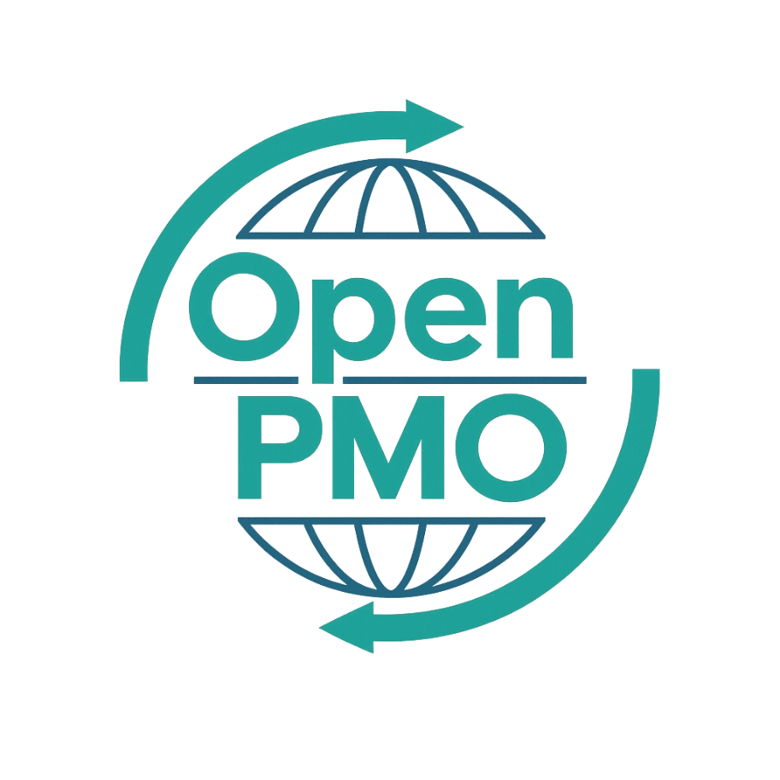
PROJECT TITLE
Business Requirements Document

Author
[Email address]

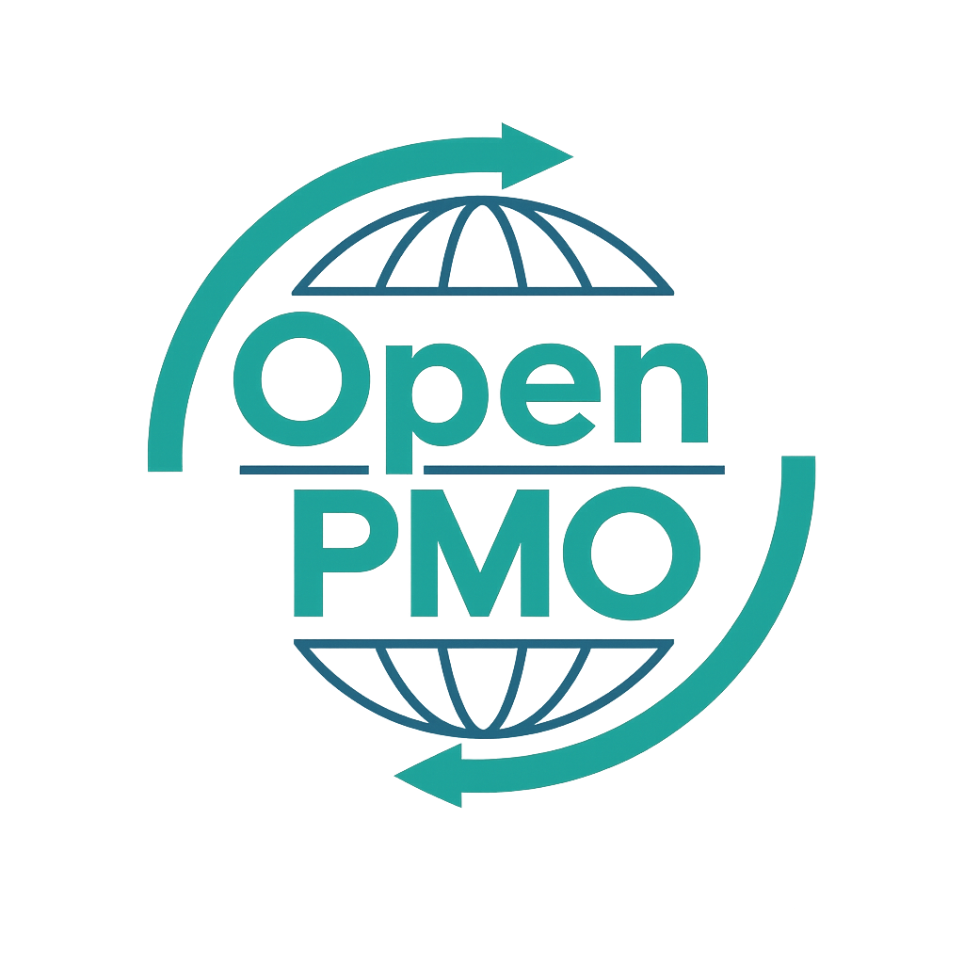
📄 Terms of Use
This resource is part of the Open PMO initiative to support project managers, business analysts, and teams with accessible, professional tools. You are welcome to use, adapt, and build upon this document freely.
1. Open Access & Adaptation
• You may copy, modify, and tailor this document for your own organisation or personal use.
• Attribution to Open PMO is appreciated but not required.
2. No Warranty or Liability
• This document is provided "as is," without warranties of any kind.
• Open PMO and its contributors are not liable for any outcomes resulting from its use or adaptation.
3. Responsibility for Customisation
• You are responsible for ensuring that any adapted version meets your organisation's legal, operational, and compliance standards.
• We recommend consulting with relevant stakeholders before implementation.
4. Respectful Use
• Please do not use this resource in ways that promote harm, discrimination, or unethical practices.
• If redistributed, do not misrepresent the original intent or authorship.

BUSINESS REQUIREMENTS DOCUMENT 1

Open PMO — Business Analysis
Business Requirements Document
Defining the business and functional requirements for delivery

Project Name | [Project Name] | Version | 1.0
Date | [DD MMM YYYY] | Author | [Name]
Business Analyst | [Name] | Status | DRAFT

Revision History
Version | Date | Changes | Author
0.1 | [Date] | Initial draft | [Name]
1.0 | [Date] | Approved for use | [Name]

1. Executive Summary
💡 2–3 sentences: what this project is, what it needs to deliver, and who has approved these requirements.

2. Business Context

2.1 Background
[Describe the business situation that has prompted this work. What is happening and why does it matter?]

2.2 Business Objectives
💡 List 3–5 measurable business objectives. Each should describe an outcome, not an activity.
- [Objective 1 — measurable outcome]
- [Objective 2 — measurable outcome]
- [Objective 3 — measurable outcome]

2.3 Strategic Alignment
[How does this initiative align to organisational strategy? Reference relevant strategic objectives or programme goals.]

3. Stakeholder Summary
💡 List key stakeholders only — full analysis in the Stakeholder Register. Focus on who has input to, or sign-off on, these requirements.
Stakeholder | Role | Type | Responsibility
 | Sponsor | Internal
 | Business Owner | Internal
 | End Users | Internal
 | Technical Lead | Internal
 | BA | Internal

4. Scope

4.1 In Scope
- [Capability or function included in this requirement set]
- [Capability or function included in this requirement set]
- [Capability or function included in this requirement set]

4.2 Out of Scope
💡 Being explicit about what is NOT in scope prevents scope creep more effectively than anything else.
- [Explicitly excluded item]
- [Explicitly excluded item]

5. Functional Requirements
💡 Each requirement must be testable and traceable. Use the priority column: M=Must have, S=Should have, C=Could have, W=Won't have this time (MoSCoW).
Req ID | Requirement | Priority | Source | Acceptance Criteria
FR-001 |  | M / S / C / W
FR-002 |  | M / S / C / W
FR-003 |  | M / S / C / W
FR-004 |  | M / S / C / W
FR-005 |  | M / S / C / W
FR-006 |  | M / S / C / W
FR-007 |  | M / S / C / W
FR-008 |  | M / S / C / W

6. Non-Functional Requirements
Req ID | Category | Requirement | Acceptance Criteria
NFR-001 | Performance
NFR-002 | Security
NFR-003 | Availability
NFR-004 | Usability

7. Assumptions, Constraints & Dependencies

7.1 Assumptions
- [Assumption — something believed to be true but not yet confirmed]
- [Assumption]

7.2 Constraints
- [Constraint — a fixed limitation on the solution, e.g. budget, technology, regulation]
- [Constraint]

7.3 Dependencies
- [Dependency — something this project relies on from another project or team]
- [Dependency]

8. Sign-off
By signing below, stakeholders confirm these requirements are complete, accurate, and approved for delivery.

Name | Role | Signature | Date
 | Business Analyst
 | Business Owner
 | Project Sponsor
 | Project Manager

© Open PMO — openpmo.org — Free to use, adapt and share.

