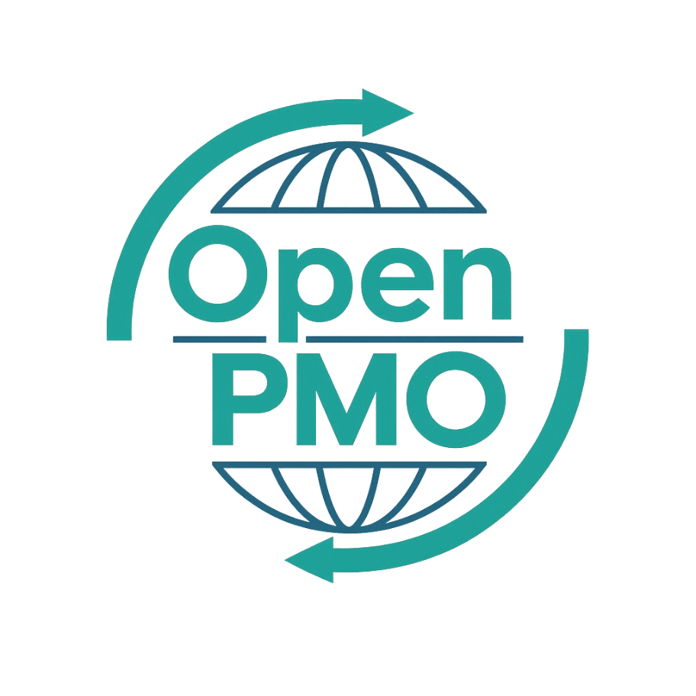
PROJECT TITLE
Lessons Learned Report

Author
[Email address]

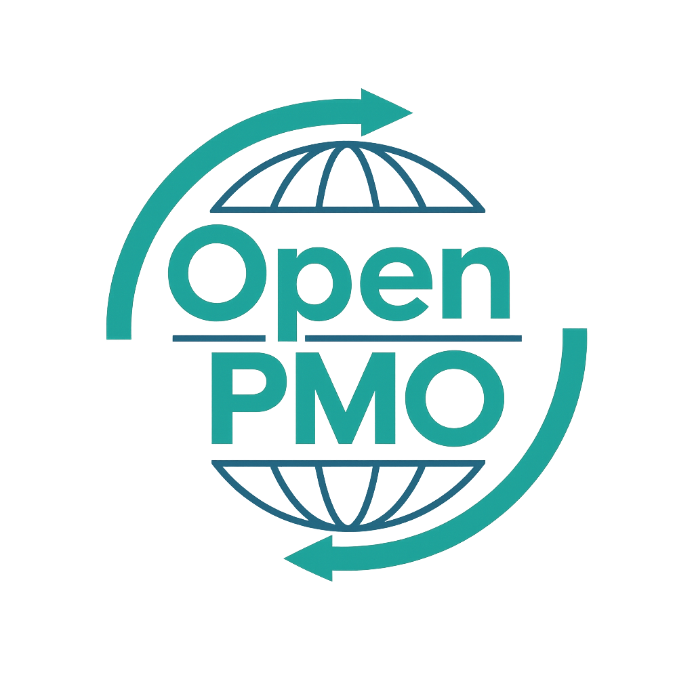
📄 Terms of Use
This resource is part of the Open PMO initiative to support project managers, business analysts, and teams with accessible, professional tools. You are welcome to use, adapt, and build upon this document freely.
1. Open Access & Adaptation
• You may copy, modify, and tailor this document for your own organisation or personal use.
• Attribution to Open PMO is appreciated but not required.
2. No Warranty or Liability
• This document is provided "as is," without warranties of any kind.
• Open PMO and its contributors are not liable for any outcomes resulting from its use or adaptation.
3. Responsibility for Customisation
• You are responsible for ensuring that any adapted version meets your organisation's legal, operational, and compliance standards.
• We recommend consulting with relevant stakeholders before implementation.
4. Respectful Use
• Please do not use this resource in ways that promote harm, discrimination, or unethical practices.
• If redistributed, do not misrepresent the original intent or authorship.

LESSONS LEARNED REPORT 1

Open PMO — Project Management Templates
Lessons Learned Report
Capturing what worked, what didn't, and how we improve next time

Project Name | [Project Name] | Version | 1.0
Date | [DD MMM YYYY] | Owner | [Name]
Project Manager | [Name] | Sponsor | [Name]

Project Name | [Name] | Project ID | [ID]
Project Manager | [Name] | Sponsor | [Name]
Review Date | [DD MMM YYYY] | Facilitator | [Name]
Attendees | [Names]

Purpose: To identify and document what went well and what could be improved, so this project's experience benefits future projects and the wider organisation. This is a no-blame exercise — all contributions are valued.

1. Project Summary
📝 Brief context for the review. What was the project trying to achieve?

2. Overall Project Assessment
📝 Rate each area honestly. These ratings inform the detailed lessons below.
Area | Excellent | Good | Fair | Poor | Comments
Governance & Sponsorship | ☐ Excellent | ☐ Good | ☐ Fair | ☐ Poor
Planning & Estimation | ☐ Excellent | ☐ Good | ☐ Fair | ☐ Poor
Risk & Issue Management | ☐ Excellent | ☐ Good | ☐ Fair | ☐ Poor
Stakeholder Engagement | ☐ Excellent | ☐ Good | ☐ Fair | ☐ Poor
Team Collaboration | ☐ Excellent | ☐ Good | ☐ Fair | ☐ Poor
Budget Management | ☐ Excellent | ☐ Good | ☐ Fair | ☐ Poor
Delivery & Quality | ☐ Excellent | ☐ Good | ☐ Fair | ☐ Poor
Change Management | ☐ Excellent | ☐ Good | ☐ Fair | ☐ Poor
Benefits Realisation | ☐ Excellent | ☐ Good | ☐ Fair | ☐ Poor
Overall Project Rating | ☐ Excellent | ☐ Good | ☐ Fair | ☐ Poor

3. What Went Well
📝 List the things the project did well that should be repeated or built upon. Be specific — examples are more valuable than generalisations.

3.1 Governance & Decision-Making
- [What went well 1]
- [What went well 2]

3.2 Planning & Delivery
- [What went well 1]
- [What went well 2]

3.3 Team & Stakeholder Collaboration
- [What went well 1]
- [What went well 2]

3.4 Tools & Processes
- [What went well 1]
- [What went well 2]

4. Areas for Improvement
📝 What would you do differently? Focus on systemic issues rather than individuals. Each point should link to a recommendation.
# | What Could Be Improved | Root Cause | Impact on Project
1
2
3
4
5
6

5. Root Cause Analysis
📝 For the top 2–3 improvement areas, dig deeper. What was the underlying cause? Use the "5 Whys" technique if helpful.

Issue 1: [Issue Title]
What happened?
Why?
Why?
Root cause

Issue 2: [Issue Title]
What happened?
Why?
Why?
Root cause

Issue 3: [Issue Title]
What happened?
Why?
Why?
Root cause

6. Recommendations
📝 Specific, actionable recommendations that should be adopted by future projects or the PMO. Each should be owned and tracked.
# | Recommendation | Applies To | Priority | Owner
1 |  | All projects / This type / PMO | High / Medium / Low
2 |  | All projects / This type / PMO | High / Medium / Low
3 |  | All projects / This type / PMO | High / Medium / Low
4 |  | All projects / This type / PMO | High / Medium / Low
5 |  | All projects / This type / PMO | High / Medium / Low
6 |  | All projects / This type / PMO | High / Medium / Low
7 |  | All projects / This type / PMO | High / Medium / Low
8 |  | All projects / This type / PMO | High / Medium / Low

7. Recognition
📝 Acknowledge individual and team contributions. Specific recognition is more meaningful than general praise.
The following individuals made a notable contribution to this project:
Name / Team | Contribution Recognised

8. Knowledge Sharing Plan
📝 How will these lessons be shared beyond the project team?
Action | Audience | Owner | Due Date
Share lessons learned report with PMO | PMO / Portfolio Board |  | [Date]
Present top 5 lessons at PM community of practice | All Project Managers |  | [Date]
Update PMO templates and standards where applicable | PMO |  | [Date]
 |  |  | [Date]
 |  |  | [Date]

9. Participant Feedback
📝 Capture the mood of the room at the end of the session. Anonymous feedback is more honest.
Please rate the following (1 = Strongly Disagree, 5 = Strongly Agree):
Statement | 1 | 2 | 3 | 4 | 5
The session was well facilitated and productive | ☐ | ☐ | ☐ | ☐ | ☐
All voices were heard equally | ☐ | ☐ | ☐ | ☐ | ☐
I understand how lessons will be acted on | ☐ | ☐ | ☐ | ☐ | ☐
I feel positive about this project's overall outcome | ☐ | ☐ | ☐ | ☐ | ☐
I would raise concerns more readily on the next project | ☐ | ☐ | ☐ | ☐ | ☐

10. Sign-off
This Lessons Learned Report is a true record of the session outcomes.
Name | Role | Signature | Date
 | Facilitator
 | Project Manager
 | Project Sponsor

© Open PMO — openpmo.org — Free to use, adapt and share.

