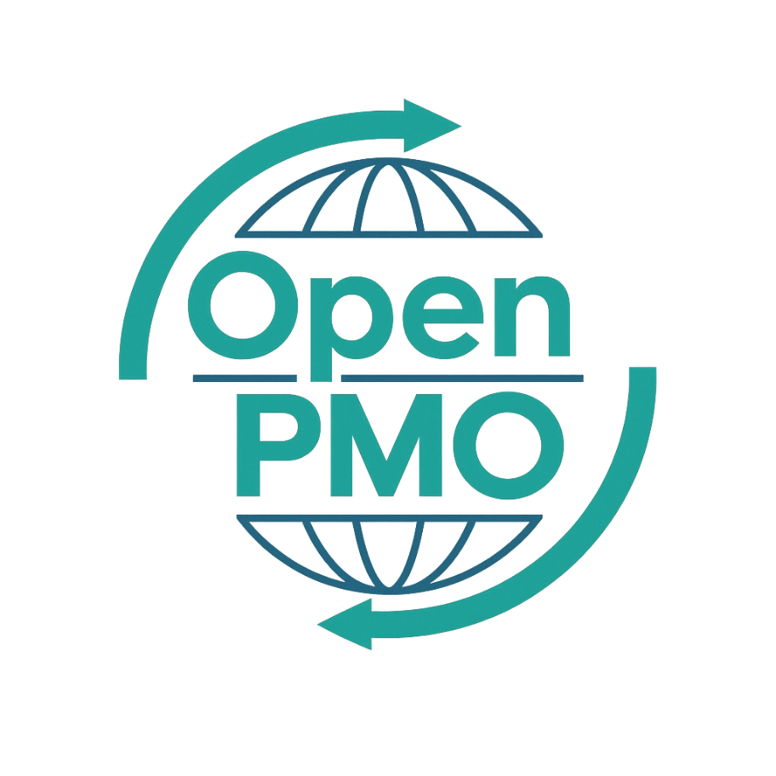
PROJECT TITLE
Communications Plan

Author
[Email address]

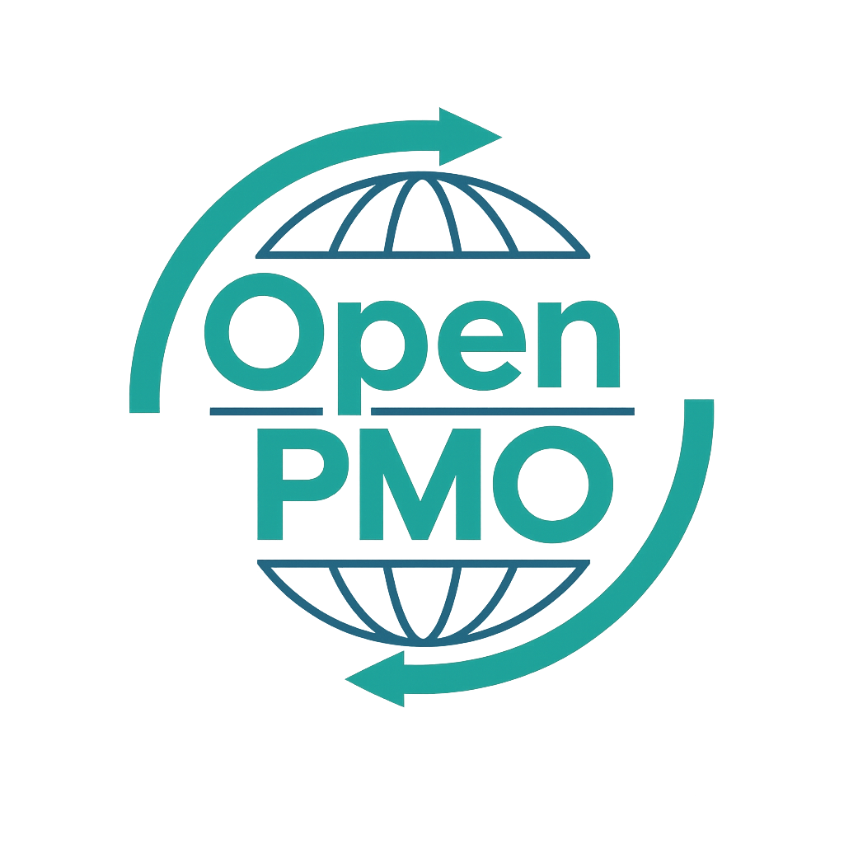
📄 Terms of Use
This resource is part of the Open PMO initiative to support project managers, business analysts, and teams with accessible, professional tools. You are welcome to use, adapt, and build upon this document freely.
1. Open Access & Adaptation
• You may copy, modify, and tailor this document for your own organisation or personal use.
• Attribution to Open PMO is appreciated but not required.
2. No Warranty or Liability
• This document is provided "as is," without warranties of any kind.
• Open PMO and its contributors are not liable for any outcomes resulting from its use or adaptation.
3. Responsibility for Customisation
• You are responsible for ensuring that any adapted version meets your organisation's legal, operational, and compliance standards.
• We recommend consulting with relevant stakeholders before implementation.
4. Respectful Use
• Please do not use this resource in ways that promote harm, discrimination, or unethical practices.
• If redistributed, do not misrepresent the original intent or authorship.

COMMUNICATIONS PLAN 1

Open PMO — Project Management Templates
Communications Plan
Defining how the project will communicate with its stakeholders

Project Name | [Project Name] | Version | 1.0
Date | [DD MMM YYYY] | Owner | [Name]
Project Manager | [Name] | Sponsor | [Name]

1. Purpose
📝 Describe why this communications plan exists and what it aims to achieve.
This Communications Plan defines how information will be shared with stakeholders throughout the [Project Name] project. It ensures the right people receive the right information at the right time, through the right channel — building confidence, managing expectations, and supporting effective decision-making.

2. Communication Objectives
📝 List 3–5 specific objectives for communication on this project.
- Ensure all stakeholders are informed of project progress, decisions, and risks in a timely manner
- Build and maintain stakeholder confidence and support throughout the project lifecycle
- Enable effective decision-making by providing accurate, concise information to the right people
- Manage expectations and minimise resistance to change
- Create a clear audit trail of all significant project communications

3. Stakeholder Audience Summary
📝 Identify the key audience groups and their communication needs. Refer to the Stakeholder Register for full detail.
Audience Group | Key Interest / Need | Preferred Channel | Level of Detail
Project Sponsor |  |  | Summary / Full / Exception only
Steering Group |  |  | Summary / Full / Exception only
Project Team |  |  | Summary / Full / Exception only
Key Stakeholders |  |  | Summary / Full / Exception only
Wider Business / Impacted Staff |  |  | Summary / Full / Exception only
Regulators / External Parties |  |  | Summary / Full / Exception only

4. Communications Matrix
📝 Define every planned communication. This is the core of the plan — keep it specific and maintained throughout the project.
Communication | Audience | Purpose | Channel / Format | Frequency | Owner
Weekly Status Report | Sponsor, Steering Group | Progress, risks, decisions needed | Email / SharePoint | Weekly | PM
Steering Group Meeting | Steering Group | Governance, escalations, decisions | Meeting / Teams | Monthly | PM
Team Stand-up | Project Team | Co-ordination, blockers, next steps | Teams / In person | Daily | PM
Stakeholder Briefing | Key Stakeholders | Updates, changes, next steps | Email / Meeting | As required | PM
Go-Live Communication | All Staff | Announce change, confirm support | Email / Town hall | One-off | BCM
Lessons Learned | Team, Stakeholders | Share outcomes and recommendations | Workshop | End of project | PM

5. Communication Schedule
📝 Map communications to the project timeline. Update as the plan evolves.
Communication | Q1 | Q2 | Q3 | Notes
Weekly Status Report | ●●●●●●●●●●●●● | ●●●●●●●●●●●●● | ●●●●●●●●●●●●● | Every Friday
Steering Group | ● ● ● | ● ● ● | ● ● ● | First Monday of month
Stakeholder Briefing | ● | ● | ● | As required
Go-Live Communication |  |  | ● | Week of go-live
Lessons Learned |  |  | ● | Final week

6. Channel Guide

6.1 Primary channels
- Email — formal updates, decisions, and records. Use for Sponsor updates, Status Reports, and anything requiring an audit trail
- Microsoft Teams — team collaboration, quick updates, meeting facilitation
- SharePoint — document storage, version control, and self-service project information
- Steering Group meetings — formal governance, decisions, and escalation resolution

6.2 Communication standards
- Status Reports use the standard OpenPMO template with RAG status
- All communications reference the project name and version number
- Meeting minutes are circulated within 24 hours of the meeting
- Urgent issues are escalated verbally first, then confirmed in writing

7. Escalation Communications
📝 Define how communications change when something goes wrong.
RAG Status | Communication Required | To Whom | Within
🟡 Amber | Exception note in status report | Sponsor | Next status report
🔴 Red | Immediate verbal/Teams briefing, followed by written exception report | Sponsor + Steering Group Chair | Within 24 hours
🔴 Critical | Emergency Steering Group convened | Full Steering Group | Within 48 hours

8. Feedback & Effectiveness
📝 How will you know the communications are working?
- Stakeholder feedback gathered at Steering Group meetings
- Project Manager checks for engagement at team stand-ups
- Communication effectiveness reviewed at each stage gate
- This plan reviewed and updated at the start of each project phase

9. Roles & Responsibilities
Role | Communication Responsibilities | Named Individual
Project Manager
Business Change Manager
Project Sponsor
PMO

© Open PMO — openpmo.org — Free to use, adapt and share.

