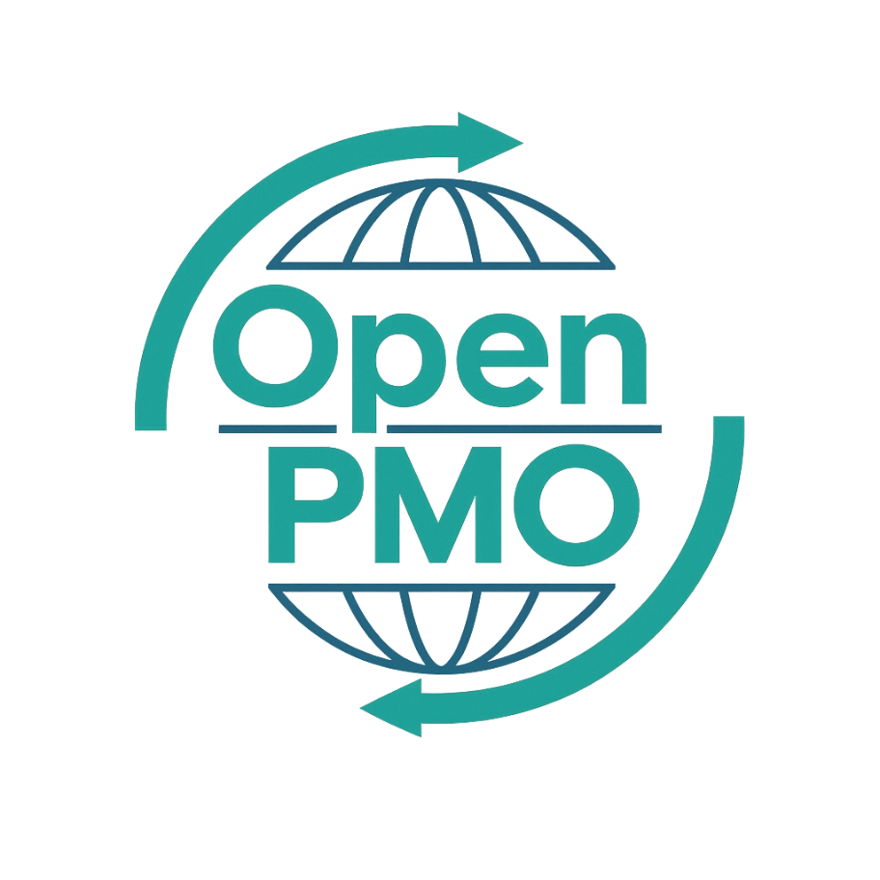
PROJECT TITLE
Programme Brief

Author
[Email address]

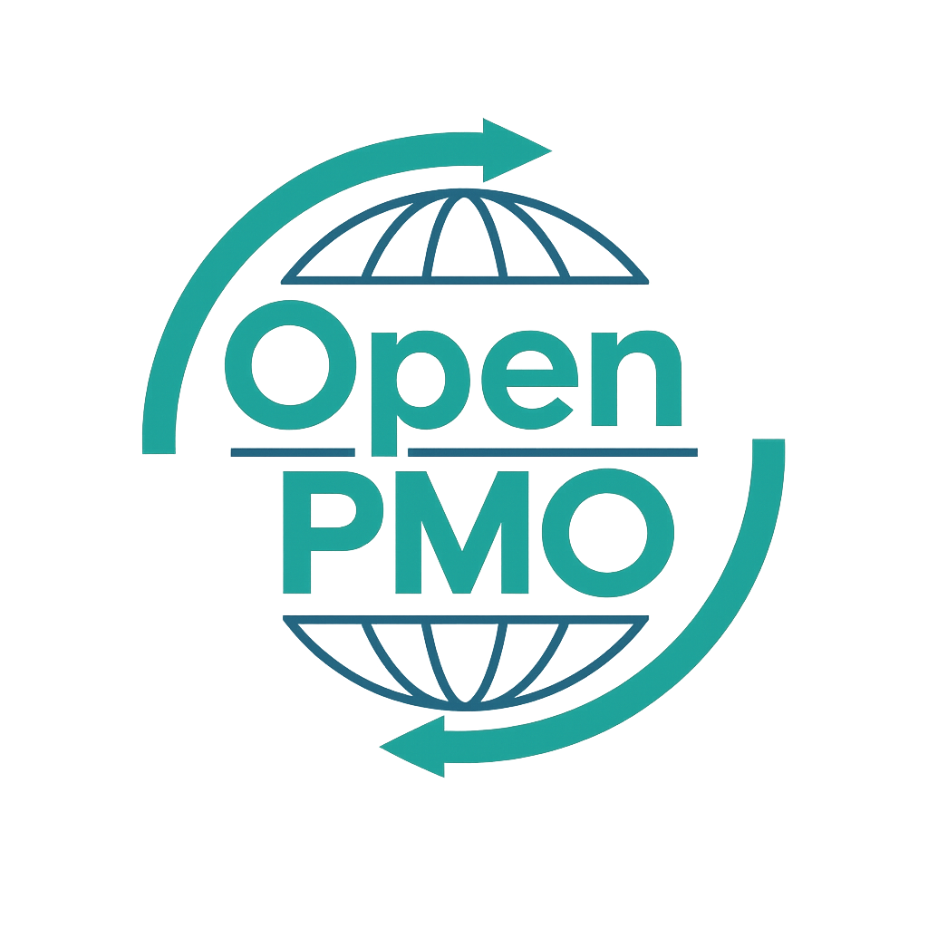
📄 Terms of Use
This resource is part of the Open PMO initiative to support project managers, business analysts, and teams with accessible, professional tools. You are welcome to use, adapt, and build upon this document freely.
1. Open Access & Adaptation
• You may copy, modify, and tailor this document for your own organisation or personal use.
• Attribution to Open PMO is appreciated but not required.
2. No Warranty or Liability
• This document is provided "as is," without warranties of any kind.
• Open PMO and its contributors are not liable for any outcomes resulting from its use or adaptation.
3. Responsibility for Customisation
• You are responsible for ensuring that any adapted version meets your organisation's legal, operational, and compliance standards.
• We recommend consulting with relevant stakeholders before implementation.
4. Respectful Use
• Please do not use this resource in ways that promote harm, discrimination, or unethical practices.
• If redistributed, do not misrepresent the original intent or authorship.

PROGRAMME BRIEF 1

Open PMO — PMO Governance Templates
Programme Brief

Defining scope, objectives and structure before full business case development
Project/Programme | [Name] | Version | 1.0
Date | [DD MMM YYYY] | Owner | [Name]

1. Programme Overview
📝 Provide a high-level description of the programme — what it will deliver and why.

2. Strategic Alignment
📝 How does this programme support the organisation's strategic objectives? Reference the relevant strategy documents.
Strategic Objective | How This Programme Contributes
[Strategic Objective]
[Strategic Objective]
[Strategic Objective]

3. Programme Objectives
📝 List 3–5 measurable objectives this programme will achieve.
- [Objective 1]
- [Objective 2]
- [Objective 3]
- [Objective 4]
- [Objective 5]

4. Constituent Projects
📝 List the projects that make up this programme. These may be refined during planning.
# | Project Name | Description | Start | End
1 |  |  | [Date] | [Date]
2 |  |  | [Date] | [Date]
3 |  |  | [Date] | [Date]
4 |  |  | [Date] | [Date]
5 |  |  | [Date] | [Date]
6 |  |  | [Date] | [Date]

5. Programme Benefits
📝 Benefits expected from the programme as a whole. Individual project benefits should be captured separately.
Benefit | Type | Value / KPI | How Measured
 | Financial / Non-Financial
 | Financial / Non-Financial
 | Financial / Non-Financial
 | Financial / Non-Financial

6. Programme Organisation
Role | Name | Responsibilities
Senior Responsible Owner (SRO)
Programme Manager
Programme Office Lead
Business Change Manager

7. Indicative Timeline
📝 High-level timeline showing programme phases and key milestones.
Phase | Description | Start Date | End Date
Programme Definition |  | [Date] | [Date]
Delivery Wave 1 |  | [Date] | [Date]
Delivery Wave 2 |  | [Date] | [Date]
Benefits Realisation |  | [Date] | [Date]
Programme Closure |  | [Date] | [Date]

8. Indicative Budget
Cost Category | Estimated Cost (£) | Notes
Internal Resource (FTE) | £
External Delivery Partners | £
Technology / Infrastructure | £
Change Management | £
Contingency (15%) | £
TOTAL | £

9. Key Risks & Assumptions

9.1 Key Risks
Risk | Probability | Impact | Initial Mitigation
 | H / M / L | H / M / L
 | H / M / L | H / M / L
 | H / M / L | H / M / L

9.2 Key Assumptions
- [Assumption 1]
- [Assumption 2]
- [Assumption 3]

10. Dependencies
📝 List significant dependencies on other programmes, projects, or external factors.
- [Dependency 1]
- [Dependency 2]
- [Dependency 3]

11. Next Steps & Approval
On approval of this Programme Brief, the following next steps will be taken:
- Establish the Programme Office and appoint the Programme Manager
- Commission full Business Case for Board approval
- Initiate individual project charters for Wave 1 projects

Name | Role | Signature | Date
 | Senior Responsible Owner
 | Portfolio Review Board Chair

© Open PMO — openpmo.org — Free to use, adapt and share.

