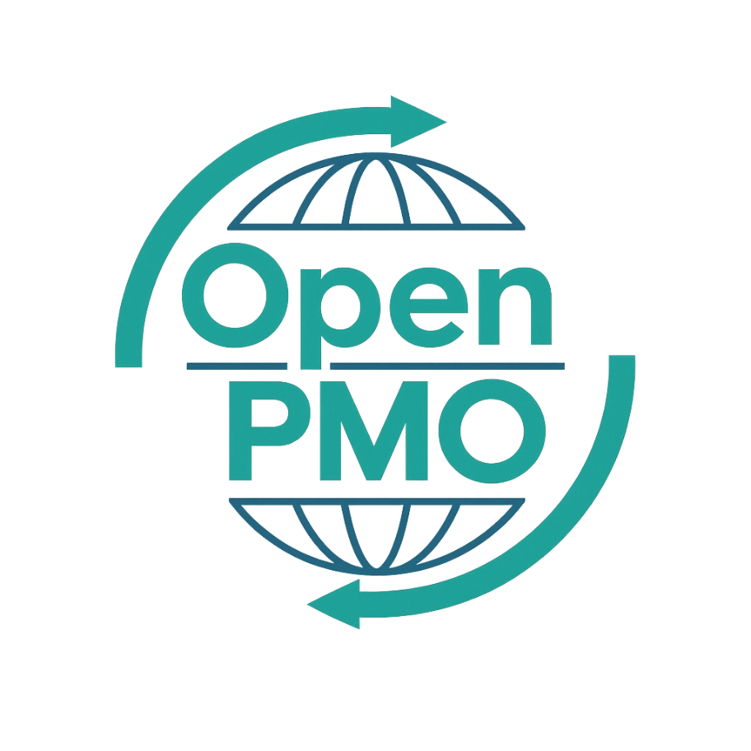
PROJECT TITLE
Post-Implementation Review

Author
[Email address]

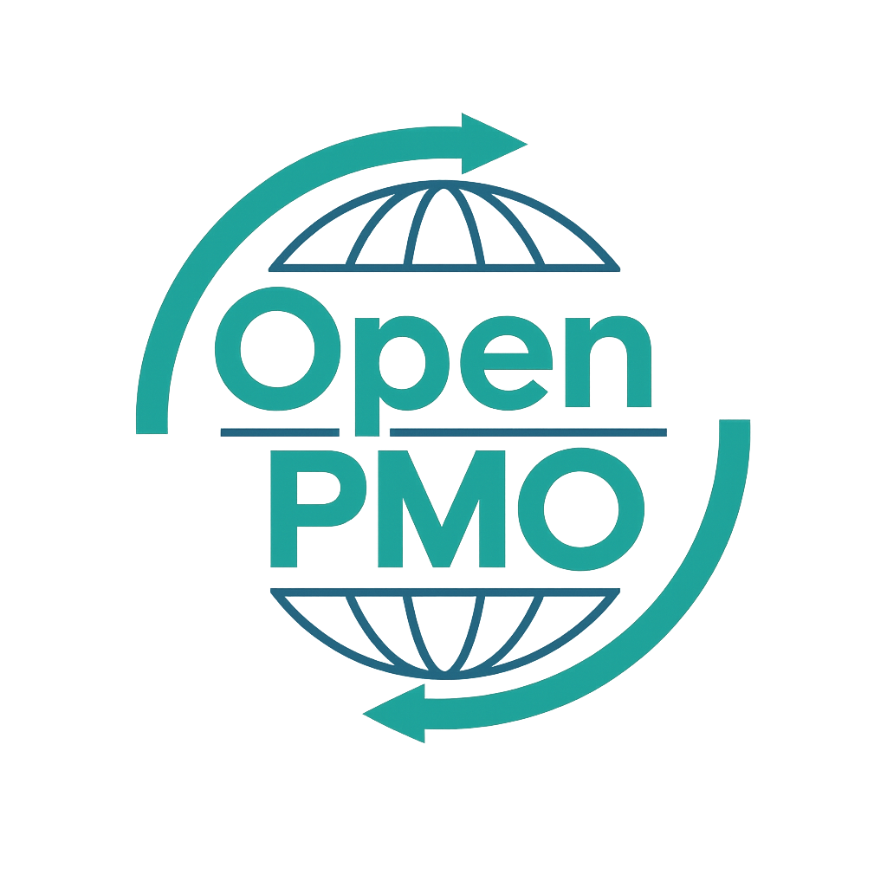
📄 Terms of Use
This resource is part of the Open PMO initiative to support project managers, business analysts, and teams with accessible, professional tools. You are welcome to use, adapt, and build upon this document freely.
1. Open Access & Adaptation
• You may copy, modify, and tailor this document for your own organisation or personal use.
• Attribution to Open PMO is appreciated but not required.
2. No Warranty or Liability
• This document is provided "as is," without warranties of any kind.
• Open PMO and its contributors are not liable for any outcomes resulting from its use or adaptation.
3. Responsibility for Customisation
• You are responsible for ensuring that any adapted version meets your organisation's legal, operational, and compliance standards.
• We recommend consulting with relevant stakeholders before implementation.
4. Respectful Use
• Please do not use this resource in ways that promote harm, discrimination, or unethical practices.
• If redistributed, do not misrepresent the original intent or authorship.

POST-IMPLEMENTATION REVIEW 1

Open PMO — PMO Governance Templates
Post-Implementation Review

Evaluating project outcomes and capturing lessons for the future
Project/Programme | [Name] | Version | 1.0
Date | [DD MMM YYYY] | Owner | [Name]

Project Name | [Name] | Project ID | [ID]
Project Manager | [Name] | Sponsor | [Name]
Original End Date | [Date] | Actual End Date | [Date]
Original Budget | £ | Final Cost | £
Review Date | [Date] | Review Facilitator | [Name]

1. Project Summary
📝 Briefly describe what the project set out to achieve.

2. Objectives vs Outcomes
📝 For each objective from the Project Charter, assess whether it was achieved.
Objective | Target | Achieved | Commentary
Objective 1 | Yes / No | Yes / Partial / No
Objective 2 | Yes / No | Yes / Partial / No
Objective 3 | Yes / No | Yes / Partial / No
Objective 4 | Yes / No | Yes / Partial / No
Objective 5 | Yes / No | Yes / Partial / No

3. Performance Summary
 | 🔴 Red | 🟡 Amber | 🟢 Green | Commentary
Schedule Performance | ☐ 🔴 Red | ☐ 🟡 Amber | ☐ 🟢 Green
Budget Performance | ☐ 🔴 Red | ☐ 🟡 Amber | ☐ 🟢 Green
Scope Delivery | ☐ 🔴 Red | ☐ 🟡 Amber | ☐ 🟢 Green
Quality of Deliverables | ☐ 🔴 Red | ☐ 🟡 Amber | ☐ 🟢 Green
Stakeholder Satisfaction | ☐ 🔴 Red | ☐ 🟡 Amber | ☐ 🟢 Green
Team Performance | ☐ 🔴 Red | ☐ 🟡 Amber | ☐ 🟢 Green
Risk Management | ☐ 🔴 Red | ☐ 🟡 Amber | ☐ 🟢 Green
Benefits Realisation | ☐ 🔴 Red | ☐ 🟡 Amber | ☐ 🟢 Green

4. Budget Analysis
Category | Approved Budget (£) | Actual Spend (£) | Variance (£)
Internal Resource | £ | £ | £
External / Suppliers | £ | £ | £
Software / Licences | £ | £ | £
Infrastructure | £ | £ | £
Other | £ | £ | £
TOTAL | £ | £ | £

5. Benefits Realisation
📝 Were the benefits in the Business Case / Benefits Realisation Plan delivered? Record actuals vs targets.
Benefit | Baseline | Target | Actual | Status
 |  |  |  | Achieved / Partial / Not Achieved
 |  |  |  | Achieved / Partial / Not Achieved
 |  |  |  | Achieved / Partial / Not Achieved

6. Lessons Learned

6.1 What went well?
📝 What should be repeated on future projects?
- [Lesson 1]
- [Lesson 2]
- [Lesson 3]
- [Lesson 4]

6.2 What could be improved?
📝 What would you do differently next time?
- [Improvement 1]
- [Improvement 2]
- [Improvement 3]
- [Improvement 4]

6.3 Recommendations for future projects
- [Recommendation 1]
- [Recommendation 2]
- [Recommendation 3]

7. Outstanding Actions
📝 Any actions that must be completed post-project or handed over to BAU.
# | Action | Owner | Due Date | Status
1 |  |  | [Date] | Open
2 |  |  | [Date] | Open
3 |  |  | [Date] | Open
4 |  |  | [Date] | Open
5 |  |  | [Date] | Open

8. Stakeholder Feedback
📝 Summarise feedback received from key stakeholders during the review.

9. Sign-off
This Post-Implementation Review has been completed and approved.
Name | Role | Signature | Date
 | Project Sponsor
 | Project Manager
 | PMO Manager

© Open PMO — openpmo.org — Free to use, adapt and share.

