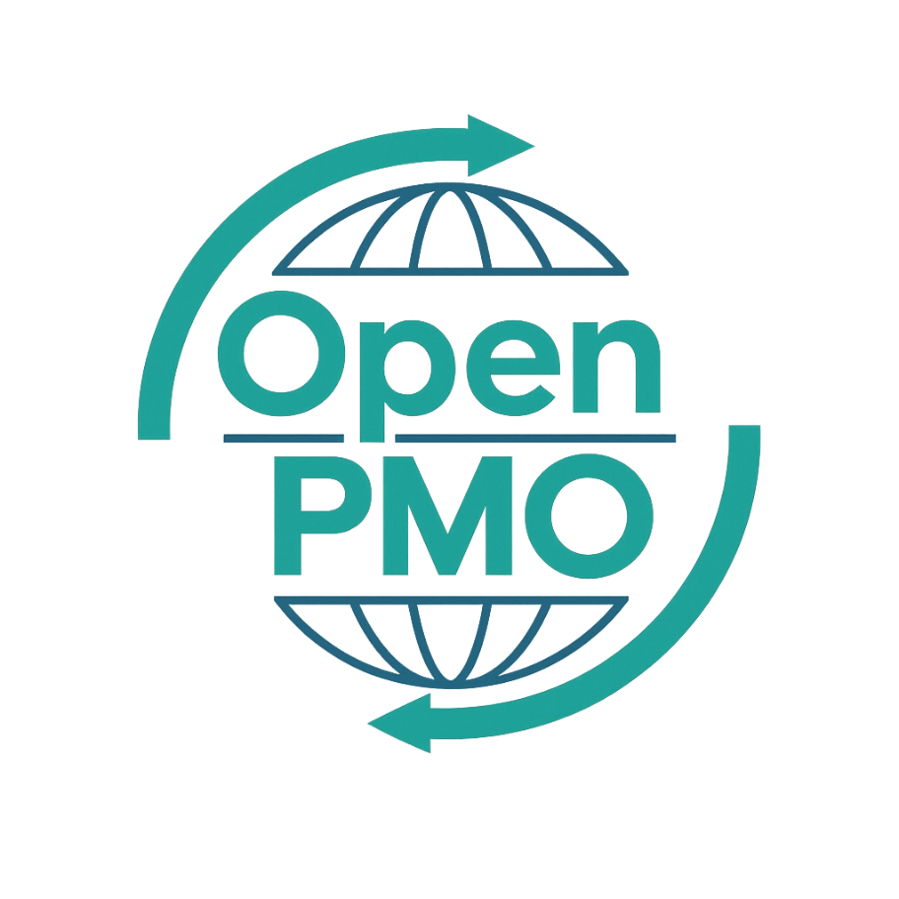
PROJECT TITLE
Governance Framework

Author
[Email address]

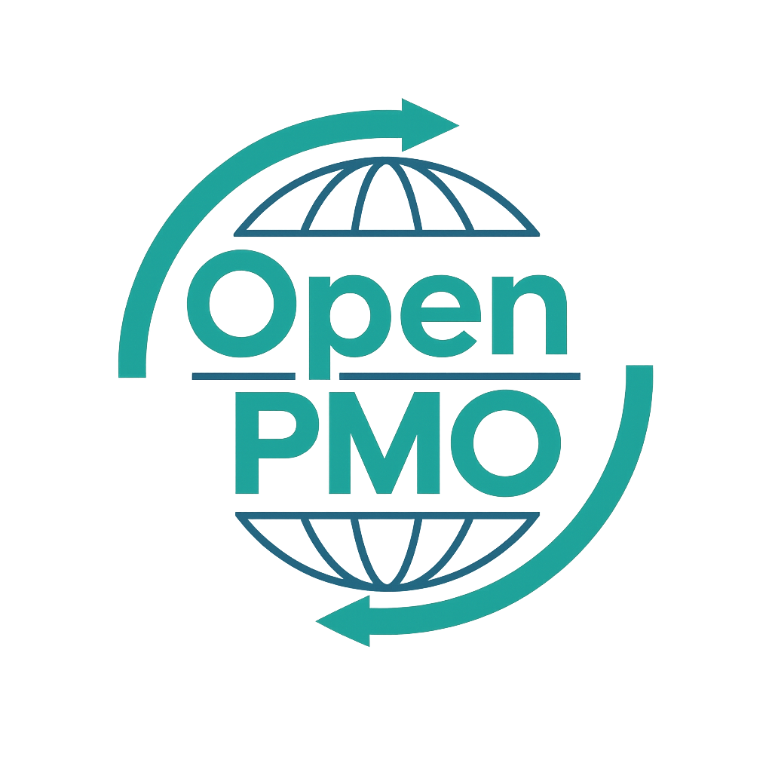
📄 Terms of Use
This resource is part of the Open PMO initiative to support project managers, business analysts, and teams with accessible, professional tools. You are welcome to use, adapt, and build upon this document freely.
1. Open Access & Adaptation
• You may copy, modify, and tailor this document for your own organisation or personal use.
• Attribution to Open PMO is appreciated but not required.
2. No Warranty or Liability
• This document is provided "as is," without warranties of any kind.
• Open PMO and its contributors are not liable for any outcomes resulting from its use or adaptation.
3. Responsibility for Customisation
• You are responsible for ensuring that any adapted version meets your organisation's legal, operational, and compliance standards.
• We recommend consulting with relevant stakeholders before implementation.
4. Respectful Use
• Please do not use this resource in ways that promote harm, discrimination, or unethical practices.
• If redistributed, do not misrepresent the original intent or authorship.

GOVERNANCE FRAMEWORK 1

Open PMO — PMO Governance Templates
PMO Governance Framework

Defining how projects are governed, approved and overseen
Project/Programme | [Name] | Version | 1.0
Date | [DD MMM YYYY] | Owner | [Name]

1. Purpose & Scope
📝 Describe why this governance framework exists and which projects/programmes it applies to.
This Governance Framework defines the structures, processes, roles, and accountabilities that govern how projects and programmes are initiated, planned, executed, and closed within [Organisation Name]. It applies to all projects with a budget exceeding [£X] or a duration greater than [X weeks].

2. PMO Mandate
📝 Define the PMO's authority level — Supportive, Controlling, or Directive.
PMO Type | Description
☑ Controlling | The PMO sets standards and requires compliance. Project managers must follow defined processes, use approved templates, and report through PMO channels.
☐ Supportive | The PMO provides templates, training, and guidance. Project managers choose whether to adopt.
☐ Directive | The PMO directly manages projects and assigns project managers.

3. Governance Structure

3.1 Governance Bodies
Body | Members | Frequency | Chaired By
Portfolio Review Board |  | Monthly / Quarterly
Project Steering Group |  | Monthly / Quarterly
PMO Operations Meeting |  | Monthly / Quarterly
Change Advisory Board |  | Monthly / Quarterly

3.2 Decision Rights Matrix
📝 Define who can approve what. RAG = who is Responsible, who Approves, who is consulted (Consulted), and who is Informed.
Decision | Sponsor | Portfolio Board | Project Manager | PMO
Approve new project (>£50k) | A
Approve new project (<£50k) | A
Approve Stage Gate passage | A
Approve Change Request (>£10k) | A
Approve Change Request (<£10k) | A
Escalate to Portfolio Board | A
Close a project | A
Approve exceptions to standards | A
Key: A = Approves R = Responsible C = Consulted I = Informed

4. Project Lifecycle & Stage Gates
📝 Define the phases a project passes through and what must be approved at each gate before proceeding.
Phase | Key Deliverables | Gate Review | Approval Required From
1. Initiation |  | Gate 1
2. Planning |  | Gate 2
3. Execution |  | Gate 3
4. Monitoring & Control |  | Gate 4
5. Closure |  | Gate 5

5. Escalation Framework
📝 Define when and how issues escalate through the governance hierarchy.
Level | Trigger | Escalated To | Timeframe
1 | Issue cannot be resolved at team level | Project Manager | Within 24 hours
2 | Issue threatens milestone or budget tolerance | Project Sponsor | Within 48 hours
3 | Issue threatens programme outcome or strategic objective | Portfolio Review Board | Next scheduled meeting or emergency session

6. Reporting Cadence
Report | Frequency | Owner | Audience
Weekly Status Report | Weekly
Monthly Portfolio Dashboard | Monthly
Stage Gate Report | As required
Exception Report | As required
Benefits Realisation Report | As required

7. Roles & Responsibilities

Project Sponsor
- Owns the business case and benefits realisation
- Chairs the Project Steering Group
- Approves stage gate passage and significant changes
- Provides senior stakeholder engagement

Project Manager
- Day-to-day management of the project
- Maintains all project documentation and registers
- Prepares and distributes status reports
- Escalates risks and issues in a timely manner

PMO Manager
- Maintains and enforces governance standards
- Provides templates, tools, and assurance
- Produces portfolio reporting for leadership
- Facilitates lessons learned and continuous improvement

8. Standards & Compliance
📝 List the standards, methodologies, or frameworks this governance framework is based on.
- PRINCE2® / PRINCE2 Agile®
- PMI PMBOK® Guide
- APM Body of Knowledge
- Organisation's Information Security Policy
- Financial Approval Policy [Reference: XX]

9. Review & Continuous Improvement
This framework will be reviewed [annually / after each major project] by the PMO Manager and approved by the Portfolio Review Board. Suggestions for improvement should be submitted to [email/channel].

© Open PMO — openpmo.org — Free to use, adapt and share.

