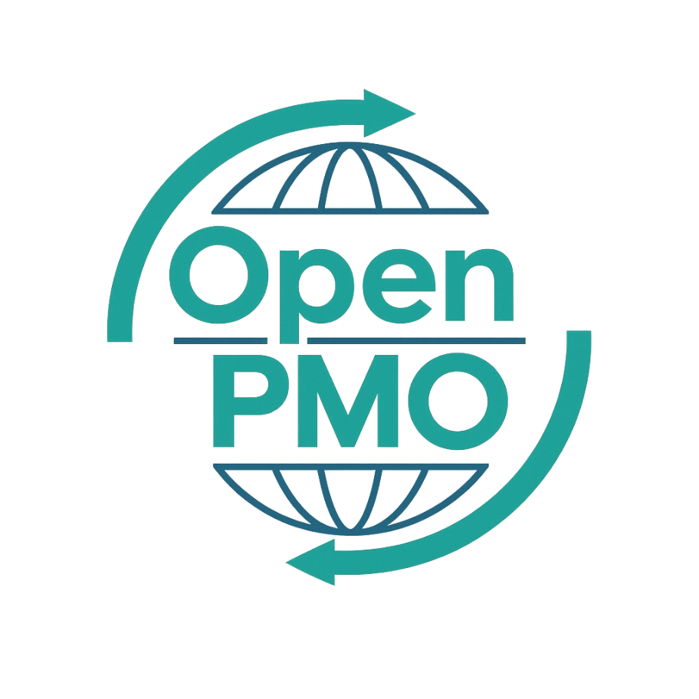
PROJECT TITLE
Change Request Form

Author
[Email address]

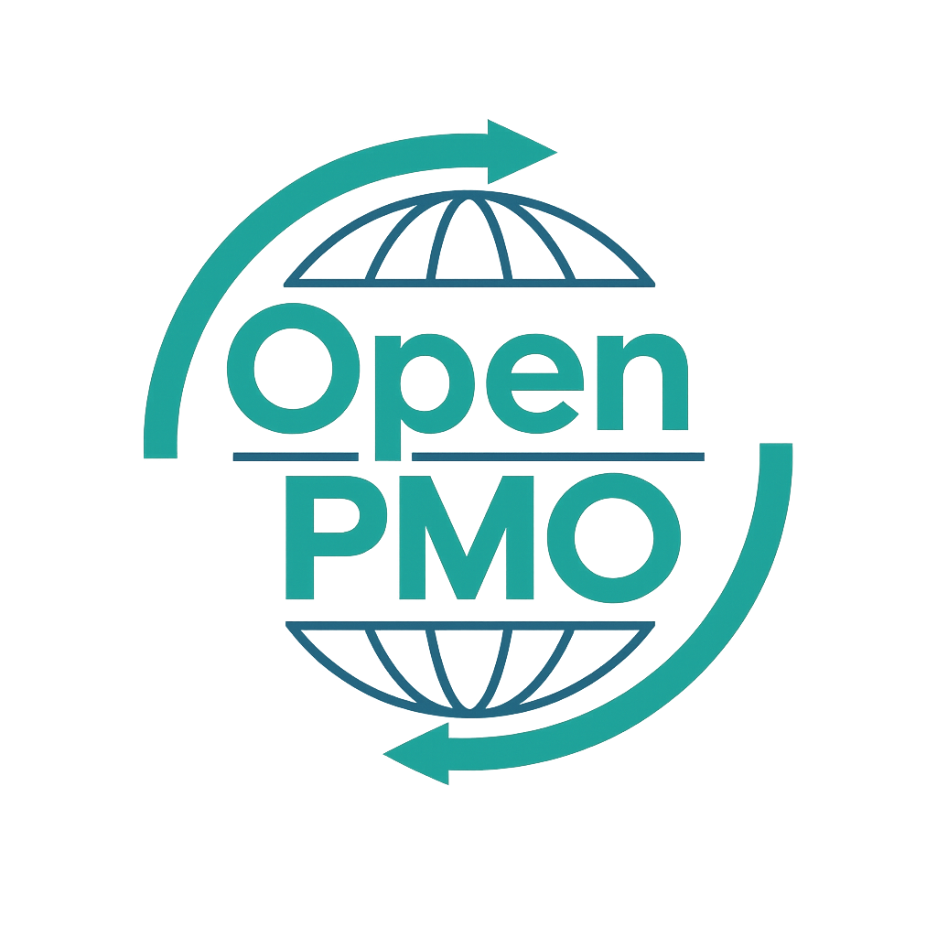
📄 Terms of Use
This resource is part of the Open PMO initiative to support project managers, business analysts, and teams with accessible, professional tools. You are welcome to use, adapt, and build upon this document freely.
1. Open Access & Adaptation
• You may copy, modify, and tailor this document for your own organisation or personal use.
• Attribution to Open PMO is appreciated but not required.
2. No Warranty or Liability
• This document is provided "as is," without warranties of any kind.
• Open PMO and its contributors are not liable for any outcomes resulting from its use or adaptation.
3. Responsibility for Customisation
• You are responsible for ensuring that any adapted version meets your organisation's legal, operational, and compliance standards.
• We recommend consulting with relevant stakeholders before implementation.
4. Respectful Use
• Please do not use this resource in ways that promote harm, discrimination, or unethical practices.
• If redistributed, do not misrepresent the original intent or authorship.

CHANGE REQUEST FORM 1

Open PMO
Change Request Form

Formal request to change project scope, cost, time or quality
Project Name | [Project Name] | Version | 1.0
Date | [DD MMM YYYY] | Status | [Draft / Final]
Project Manager | [Name] | Sponsor | [Name]

Change Ref # | CR-[001] | Date Raised | [DD MMM YYYY]
Requested By | [Name / Role] | Priority | High / Medium / Low

1. Change Description
📝 Describe the change clearly and concisely. What is being requested and why?

2. Reason / Justification
📝 Why is this change needed? What happens if it is not approved?

3. Impact Assessment
📝 Assess the impact of implementing this change across each dimension.
Impact Area | None | Minor | Major | Details
Scope | ☐ | ☐ | ☐
Schedule / Timeline | ☐ | ☐ | ☐
Budget / Cost | ☐ | ☐ | ☐
Quality | ☐ | ☐ | ☐
Resources | ☐ | ☐ | ☐
Risk | ☐ | ☐ | ☐
Stakeholders | ☐ | ☐ | ☐

4. Schedule Impact
Original End Date | [DD MMM YYYY] | Revised End Date | [DD MMM YYYY]
Original Budget | £ | Additional Cost | £

5. Options Considered

Option A — Implement as requested

📝 Describe this option and its pros/cons.

Option B — Implement a reduced scope

📝 Describe a scaled-back alternative if applicable.

Option C — Do not implement

📝 Describe what happens if the change is rejected.

6. Recommendation
📝 Which option do you recommend and why?

7. Approval
Name | Role | Decision | Date / Signature
 | Project Manager | Approved / Rejected / Deferred
 | Project Sponsor | Approved / Rejected / Deferred
 | Finance (if budget impact) | Approved / Rejected / Deferred

8. Implementation Notes
📝 Once approved, record here how and when the change was implemented.

© Open PMO — openpmo.org

