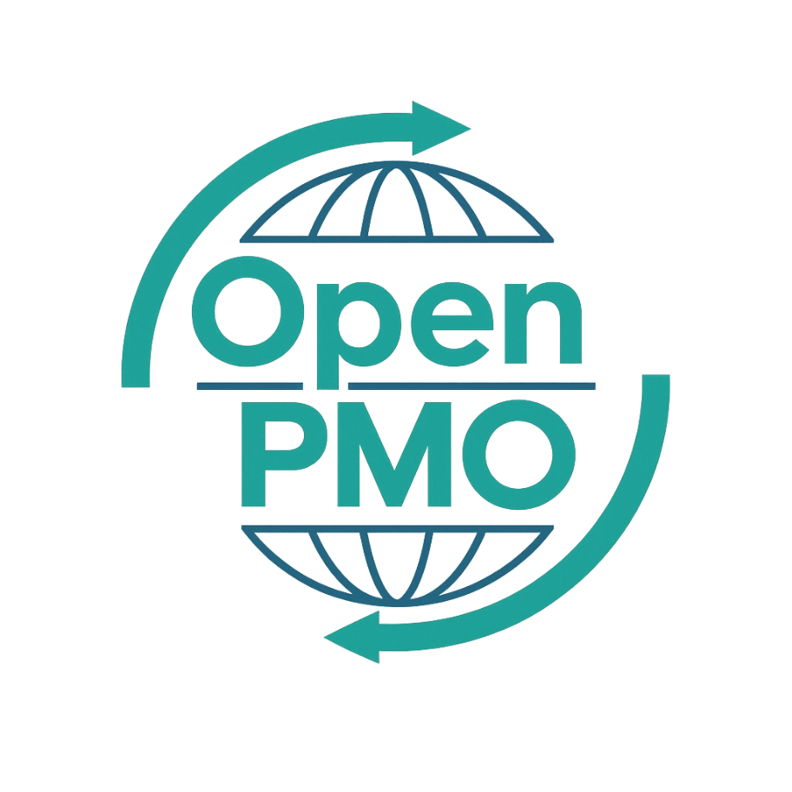
PROJECT TITLE
Weekly Status Report

Author
[Email address]

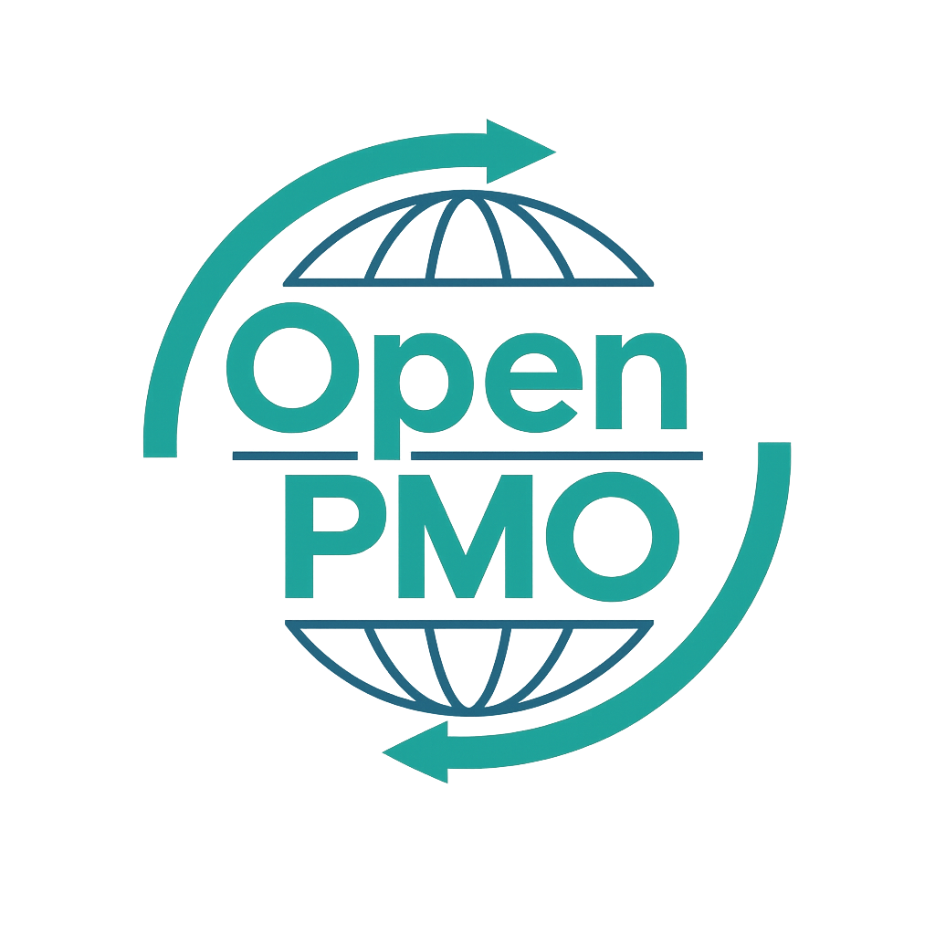
📄 Terms of Use
This resource is part of the Open PMO initiative to support project managers, business analysts, and teams with accessible, professional tools. You are welcome to use, adapt, and build upon this document freely.
1. Open Access & Adaptation
• You may copy, modify, and tailor this document for your own organisation or personal use.
• Attribution to Open PMO is appreciated but not required.
2. No Warranty or Liability
• This document is provided "as is," without warranties of any kind.
• Open PMO and its contributors are not liable for any outcomes resulting from its use or adaptation.
3. Responsibility for Customisation
• You are responsible for ensuring that any adapted version meets your organisation's legal, operational, and compliance standards.
• We recommend consulting with relevant stakeholders before implementation.
4. Respectful Use
• Please do not use this resource in ways that promote harm, discrimination, or unethical practices.
• If redistributed, do not misrepresent the original intent or authorship.

WEEKLY STATUS REPORT 1

Open PMO
Weekly Status Report

Project progress and exception report
Project Name | [Project Name] | Version | 1.0
Date | [DD MMM YYYY] | Status | [Draft / Final]
Project Manager | [Name] | Sponsor | [Name]

Report Period | [DD MMM] to [DD MMM YYYY] | Report # | [001]

1. Overall RAG Status
📝 RAG = Red / Amber / Green. Delete the two colours that do not apply in each row.
Area | 🔴 Red | 🟡 Amber | 🟢 Green
Overall Project Status |  |  | ✓
Schedule / Timeline |  |  | ✓
Budget |  |  | ✓
Resources |  |  | ✓
Risks & Issues |  |  | ✓
Stakeholder Engagement |  |  | ✓

2. Executive Summary
📝 2–3 sentences for senior stakeholders. What is the headline message this week?

3. Progress This Week
📝 What was completed or progressed? Be specific — reference milestones, deliverables, or decisions.
- [Achievement 1]
- [Achievement 2]
- [Achievement 3]

4. Planned Next Week
📝 What is the plan for the coming week?
- [Planned activity 1]
- [Planned activity 2]
- [Planned activity 3]

5. Key Risks & Issues
📝 Top risks and issues requiring attention. Use the RAID Log for full detail.
Type | Description | RAG | Owner | Action Required | Due
R |  | R / A / G
R |  | R / A / G
I |  | R / A / G
I |  | R / A / G

6. Decisions Required
📝 Any decisions needed from the Sponsor or Steering Group this week.
Decision Required | Decision Maker | Required By | Status
 |  | [Date] | Pending
 |  | [Date] | Pending

7. Budget Summary
 | Approved (£) | Spent to Date (£) | Forecast (£) | Variance (£)
Total Budget | £ | £ | £ | £
Internal Resource | £ | £ | £ | £
External / Supplier | £ | £ | £ | £
Contingency | £ | £ | £ | £

8. Next Milestone
Milestone | Planned Date | Forecast Date | Status
 | [Date] | [Date] | On Track / At Risk / Delayed
 | [Date] | [Date] | On Track / At Risk / Delayed
 | [Date] | [Date] | On Track / At Risk / Delayed

© Open PMO — openpmo.org

