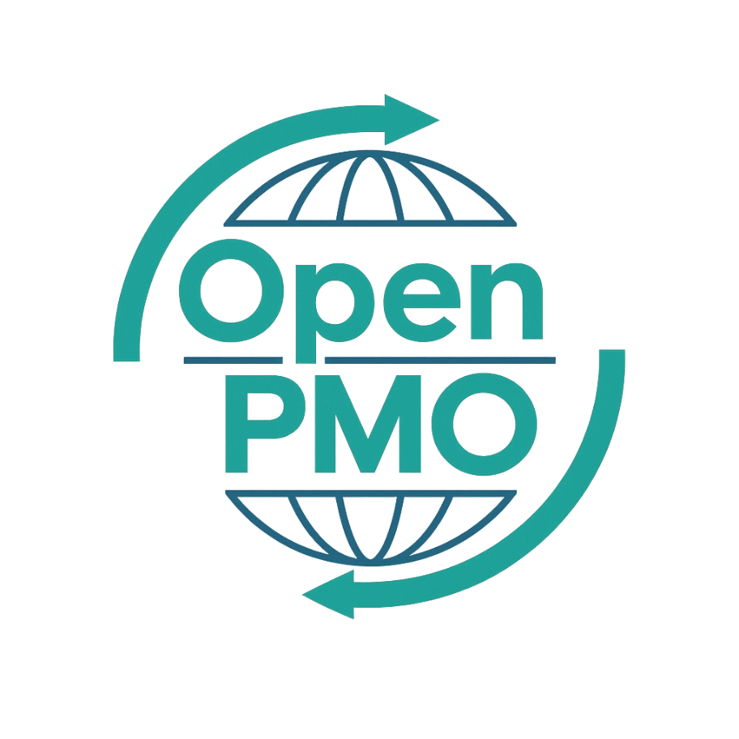
PROJECT TITLE
Project Charter

Author
[Email address]

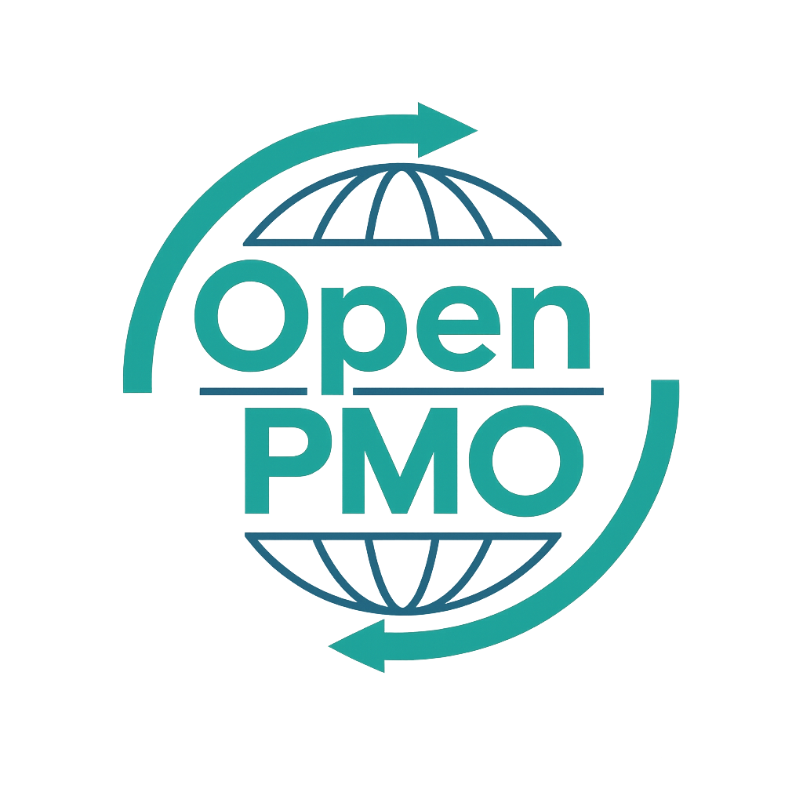
📄 Terms of Use
This resource is part of the Open PMO initiative to support project managers, business analysts, and teams with accessible, professional tools. You are welcome to use, adapt, and build upon this document freely.
1. Open Access & Adaptation
• You may copy, modify, and tailor this document for your own organisation or personal use.
• Attribution to Open PMO is appreciated but not required.
2. No Warranty or Liability
• This document is provided "as is," without warranties of any kind.
• Open PMO and its contributors are not liable for any outcomes resulting from its use or adaptation.
3. Responsibility for Customisation
• You are responsible for ensuring that any adapted version meets your organisation's legal, operational, and compliance standards.
• We recommend consulting with relevant stakeholders before implementation.
4. Respectful Use
• Please do not use this resource in ways that promote harm, discrimination, or unethical practices.
• If redistributed, do not misrepresent the original intent or authorship.

PROJECT CHARTER 1

Open PMO
Project Charter

Formal authorisation to initiate a project
Project Name | [Project Name] | Version | 1.0
Date | [DD MMM YYYY] | Status | [Draft / Final]
Project Manager | [Name] | Sponsor | [Name]

1. Project Overview
📝 Provide a concise description of what this project will deliver and why it is being undertaken.

2. Business Case & Objectives

2.1 Problem / Opportunity
📝 What problem does this project solve, or what opportunity does it realise?

2.2 Objectives
📝 List 3–5 SMART objectives. Each should be Specific, Measurable, Achievable, Relevant, and Time-bound.
- [Objective 1]
- [Objective 2]
- [Objective 3]

2.3 Benefits
📝 What tangible benefits will the organisation realise as a result of this project?

3. Scope

3.1 In Scope
📝 List everything this project will deliver or address.
- [In scope item 1]
- [In scope item 2]

3.2 Out of Scope
📝 Explicitly state what this project will NOT cover, to manage stakeholder expectations.
- [Out of scope item 1]
- [Out of scope item 2]

4. Stakeholders
📝 List the key people involved in or affected by this project.
Name | Role / Title | Organisation | Interest
 | [Sponsor Name]
 | [PM Name]

5. Timeline
📝 Provide the key phases and dates. Refine in the project plan once approved.
Phase / Milestone | Planned Start | Planned End | Owner
Initiation | [Date] | [Date]
Planning | [Date] | [Date]
Execution | [Date] | [Date]
Monitoring & Control | [Date] | [Date]
Closure | [Date] | [Date]

6. Budget
Cost Category | Estimated Cost (£) | Notes
Internal resource | £
External / Contractor | £
Software / Licences | £
Infrastructure | £
Contingency (10%) | £
TOTAL | =SUM above

7. Assumptions & Constraints

7.1 Assumptions
📝 List what is assumed to be true. If assumptions prove incorrect, the project may need to be re-scoped.
- [Assumption 1]
- [Assumption 2]

7.2 Constraints
📝 List fixed constraints such as budget caps, regulatory deadlines, or technology restrictions.
- [Constraint 1]
- [Constraint 2]

8. Key Risks
📝 High-level risks only — use the Risk Register for full detail.
Risk Description | Probability | Impact | Mitigation
 | H / M / L | H / M / L
 | H / M / L | H / M / L
 | H / M / L | H / M / L

9. Success Criteria
📝 How will we know this project has been successful? Define measurable outcomes.
- [Success criterion 1]
- [Success criterion 2]
- [Success criterion 3]

10. Approvals
📝 Signatures confirm authorisation to proceed. Obtain before moving to planning.
Name | Role | Signature | Date
 | Project Sponsor
 | Project Manager
 | Finance Approval

© Open PMO — openpmo.org — Free to use, adapt and share.

